Visit of Director TDAP Islamabad to Mirpur (AJ&K)
( 26-Jan-2021 )

On the direction of Director General TDAP Islamabad, Mr. Muhammad Ishaq Shinwari (Director), Mr. Muhammad Tahsin (Deputy Director) and Mr. Shakeel Abbasi (Superintendent) visited TDAP Mirpur office to hold meetings with different stakeholders including officials from Industrial Estate AJ&K, Mirpur Chamber of Commerce and Industry (MCCI) and exporters of foam, matches, ghee and other food items. The purpose of all these meetings was to create close liaison with the trader community of AJ&K and explore potential exports of the region.
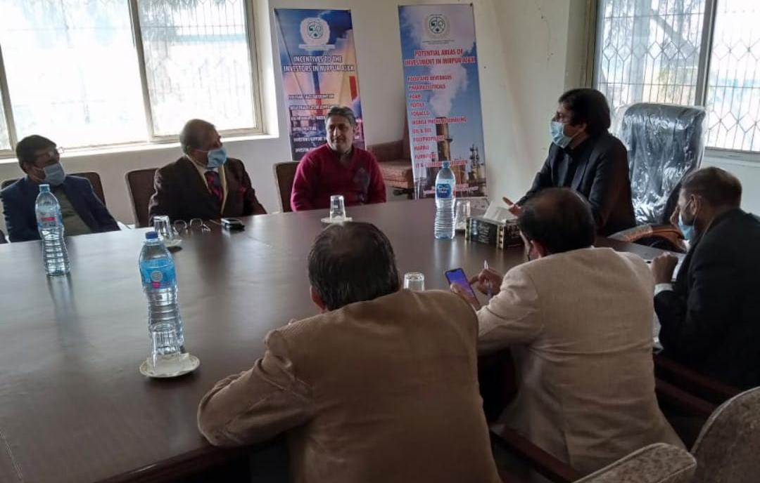

The Director TDAP Islamabad visited the Industrial Estate AJ&K and held meeting with the Director and other participants of the meeting including representatives from different industries. The Director Industrial Estate welcomed the TDAP team and briefed them about establishment of different industrial units in the IE. The Director TDAP informed the participants about the organization, its functions and role. He also mentioned the possible support which can be extended to the existing and potential exporters in areas such as capacity building, marketing etc. Most of the observations and issues raised by the industrialists and manufacturers were related to Industry Department AJ&K, Ministry of Industry and FBR.
Furthermore, the Director TDAP and his team also visited the office of MCCI and held meeting with the V. President, other members and General Secretary of the Chamber. The V. President welcomed the TDAP Team and briefed them regarding the role of MCCI in business and trade promotion in their region. Director TDAP mentioned how the organization is working for the export promotion of the country in close liaison with the trade bodies and Trade and Invest Officers posted in Pakistani missions abroad.

*******************************************************************

