Government of Pakistan
Trade Development Authority of Pakistan
Directorate General Islamabad

****

Meeting of DG TDAP Islamabad with President Vehari Chamber of Commerce & Industry
( 28-Jan-2021 )

In a meeting chaired by Mr. Shahzad Ahmed Khan (Director General TDAP Islamabad) and participated Mr. Hafiz Mehmood Ahmad Shah (President VCCI) along with other senior members of the chamber, the mandate of TDAP in trade development was discussed. Mr. Shah apprised the Director General that the products of their region were acquired by the firms from bigger cities to participate in local and foreign exhibitions, leaving the producers with minimum returns. He added that the Vehari chamber wishes adequate participation for the Vehari based firms in all relevant local and foreign exhibitions.
Responding to the concerns of the business community, the Director General explained step by step process of exporter-development including identification of potential export industries and competitiveness enhancement through establishment of trading houses and common facilities like testing labs, certifications and accreditations. In addition, the process of project submission to EDF was discussed.

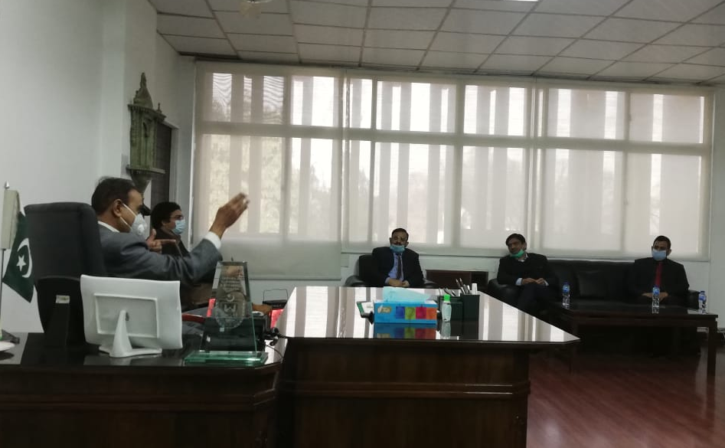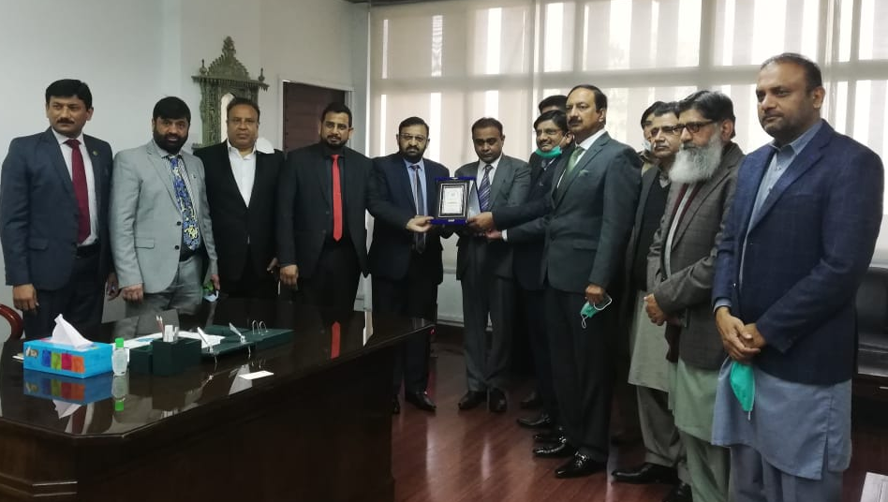

The meeting was ended with thanks.

*******************************************************************

