No. TDAP-1(6)/2016/ Swat the 1st December, 2020

MONTHLY PRODUCT PROGRESS /ACTIVITIES REPORT FOR THE MONTH OF NOVEMBER, 2020

Name & Designation of Officer: Mr. Noman Bashir, Deputy Director, TDAP, SRO Swat.

S# | Main Activity | Expected Outcome | Progress for October, 2020 | Way Forward for December, 2020
 | PRODUCT NAME: DRY FRUITS
1. | A meeting was held on 26th November, 2020 with owner of Marble Factory in Swat and discussed export of marble and marble products to China and other countries in detail. Attended & disseminated information regarding webinars on “Market opportunities for Pakistani Handicrafts in the Chinese market (Beijing)” on 20-11-2020 and webinar on “Food Export Opportunities & Future of Packing in the EU” on 27-11-2020. | The lists of foreign buyers of dry fruits have not been supplied to this office by our missions abroad so far, however, we are in touch and it is hoped that the same will be received soon. Handicrafts dealers and exporters have contacted this office for supply of contact address of Mr. Badar –uz-Zaman, Trade & Investment Counselor, Embassy of Pakistan, China which were provided them for further n/a. | - Requests of the dry fruits traders have been taken up with Commercial Counselors in China for providing lists of dry fruits importers. | - Follow up of our contacts with Commercial Counselors in China regarding export of dry fruits.  - Exploring new markets through our missions abroad for export of Swati based products.

Carry Over Activities September,2020 | Reason for Non-Execution | Progress November, 2020 | Way Forward November, 2020
Arrangements of Seminars, Webinars and Workshops. | - Not approved by the competent authority so far. | NIL | NIL

PHOTO GALLERY OF MEETING.
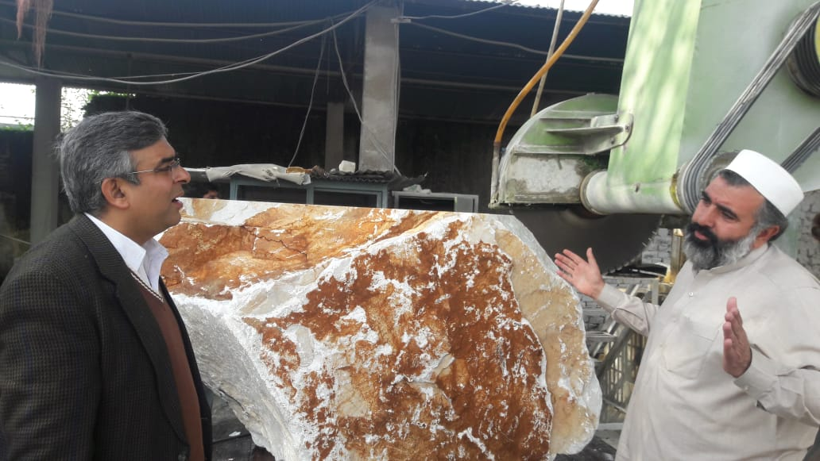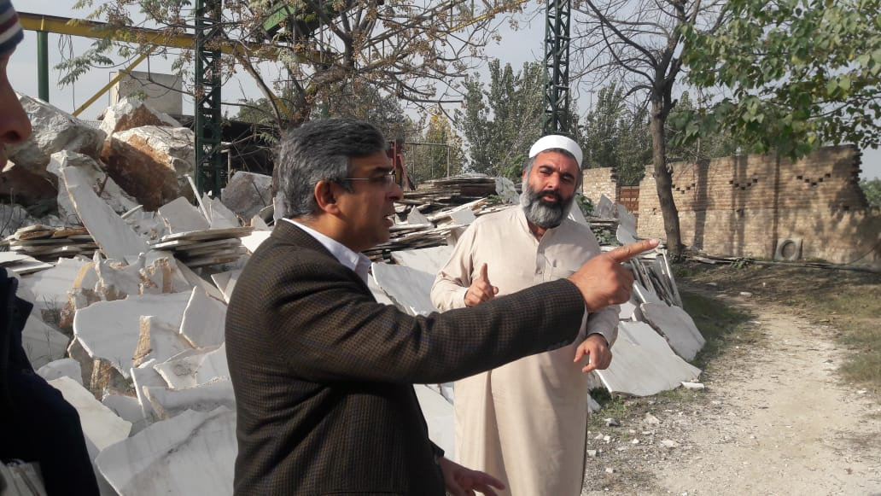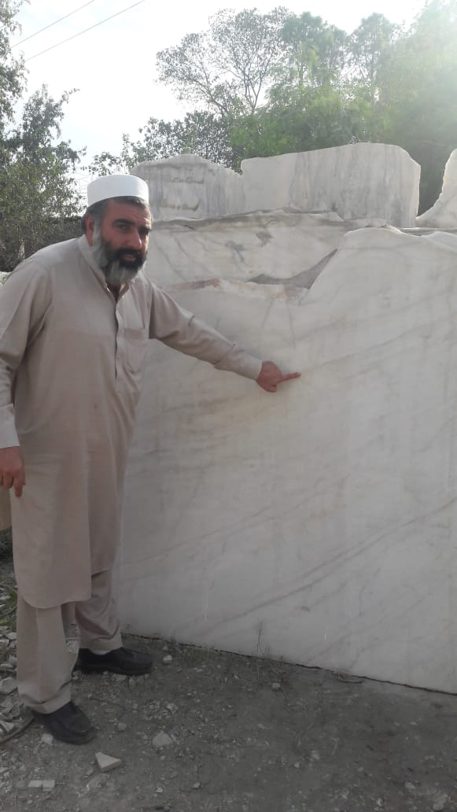

Sd/-
(Noman Bashir)
Deputy Director
TDAP, SRO, Swat

