Training Report

Product Design Training
Conduct For: Women Chamber of Commerce Multan

Trainer: SABAH Pakistan,
51-B/1 off MM Alam Road, Gulberg III
Lahore.
+92-42-35764408
http://www.sabahpak.org/

Date of event: 14-16th January 2022

Resource Persons:
Senior Trainer: Asma Ravji
Master trainer quality controller: Khalida Bibi
Product Designer: Tanveer Ali

INTRODUCTION
A three-day training of product designing was conducted for Women Chamber of Commerce Multan by SABAH Pakistan. Training was planned according to the requirement of the trainees.
The objective of the training was to design new products, help them improve finishing of their products according to the standards of ntional and international market.

Day One:
The workshop started with each candidate filling up information form about their business, product line, their skills, literacy level, business turnover and marketing channels they are using to market their products.
Based on the information gathered, they were further asked to state their one strengths and challenges that they think can be further improved.
Their main strengths were high quality craft skills in multiple embroideries from the area. There were quite a few challenges such as lack of diversity in work, low growth, marketing options, digital marketing and limited access to national international market and exhibitions.
After a detailed discussion on their strengths and challenges, in an interactive session they were asked to display their products one by one and to analyse their understanding and standard of work.
The quality of their embroidery was good; some products were exceptionally detailed and very labour extensive.
The main challenges were colour combinations, low quality fabric to save cost, low selling prices. Market saturation, they were competing with low quality products available at retail shop in the local market.
Feedback on their products made them aware of issues that were creating hurdles for their business growth.
The next session was on the concepts of colour wheel (including primary, secondary and tertiary colours), colour tones and combinations and same colour family. The concept was explained through detailed presentation in an interactive session. They were asked to go out and identify different colour combinations, tones and shades they could see in nature.
The workshop ended with colouring exercise where candidates were asked to make different shades from the selected primary colours. All of them thoroughly enjoyed the colouring session and made their sample pallets on paper sheets. They were also asked to choose a colour palette for different products.

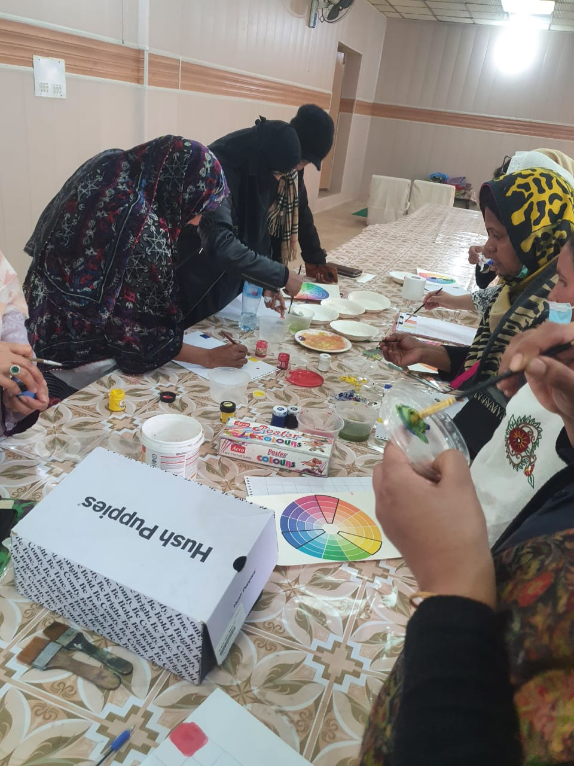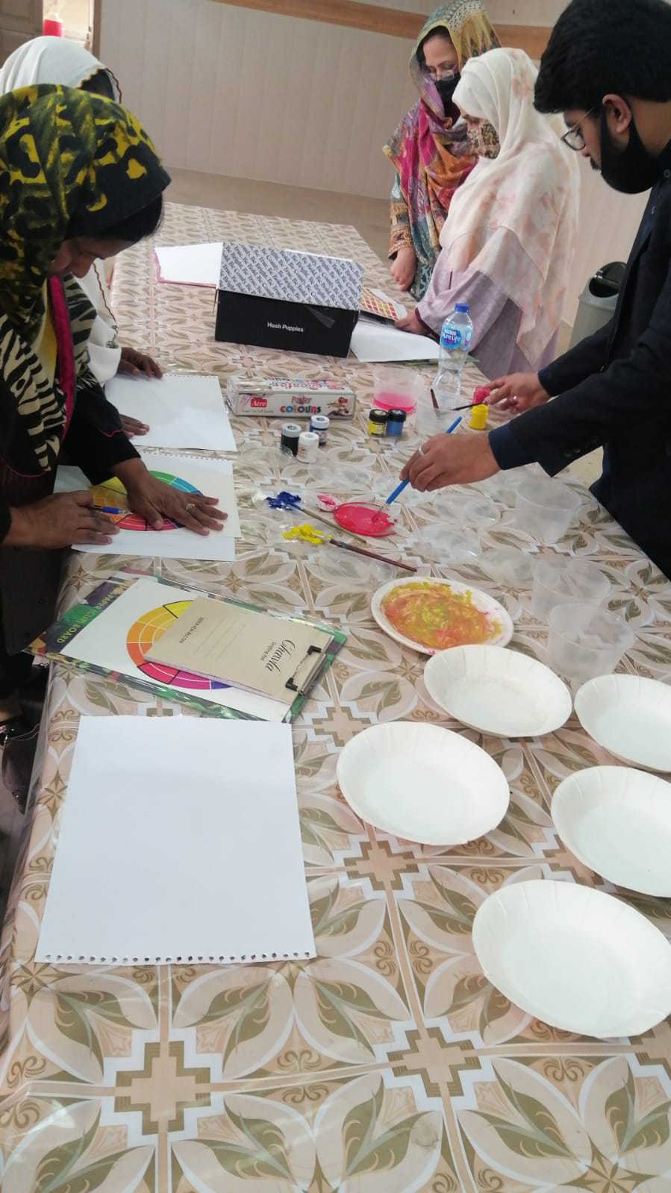
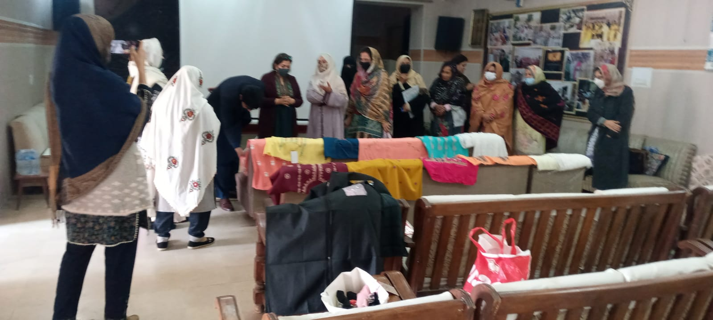

Day Two:
Continuation of colour palette exercise. Participants showed their selection of colour palettes to the product designers and made changes on the basis of feedback.
Those members who couldn’t bring their products to show on day one, displayed their products. Interactive session with members continued to discuss what is most valuable and what is lacking in their designs, colour combinations and cuts.
High quality product samples from SABAH Pakistan were displayed for them to understand difference between good quality material, design and high-end products. A detailed discussion was carried out to explain the difference between high quality finishing based on the samples shown and how it affects overall quality of the product.
The next session was on product design/ diversification. It was explained through a presentation, where different products with the same craft / skill were made according to the market demand. The participants were introduced to different design resources such as Pinterest and how they can get inspiration from internet and research.
Based on the product development session the participants were asked to come up with ideas and decide which product they would like to make as sample. They all wated to diverge from apparel and try something new such as accessories / home accessories. The apparel in same embroidery has already saturated the market, either they look for new market outside Multan / their hometowns or switch to new products line to attract customer.
Khalida Bibi the master trainer from SABAH shared with them her story of success and how she started with a small machine and now her products are hostelling items at national and international market. Her two products (mobile covers and Passport bags) were selected by the craft experts helping government to shortlist products for Dubai expo 2020. She explained how she prepares international orders and how important is to meet the timeline and high-quality standards if they want to expand their business from local to national and international level.
The participants decided to learn to stich Mobile cover, Tea-cozy and doorbell from Khalida Bibi from the start to finish. They were asked to bring their embroidered material to prepare sample of product they have decided to make.

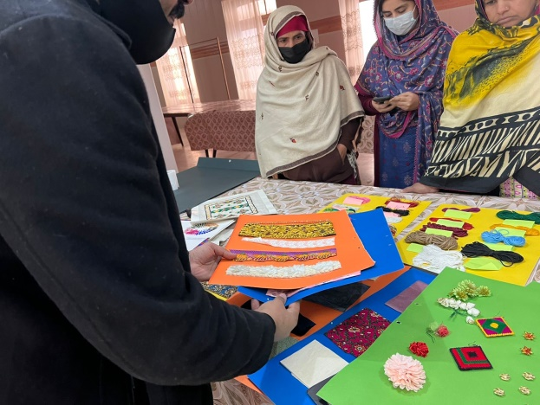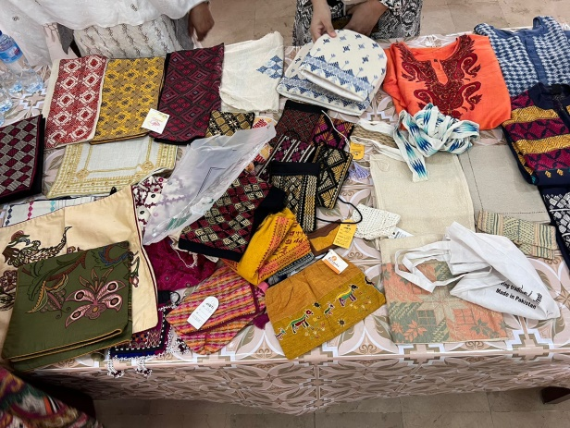
Day Three:
Khalida Bibi the master trainer started the day with training on cutting, stitching and finishing of three products selected by the participants. Samples of all three products, mobile cover, Tea-cozy and doorbell were made. Khalida Bibi explained each step, especially the finishing of each product and why this stage is most challenging.
The workshop was ended with a detailed presentation on marketing strategies and why it’s so important to expand their business. The participants found this very informative.
The participants were asked to fill in the feedback forms on the training.
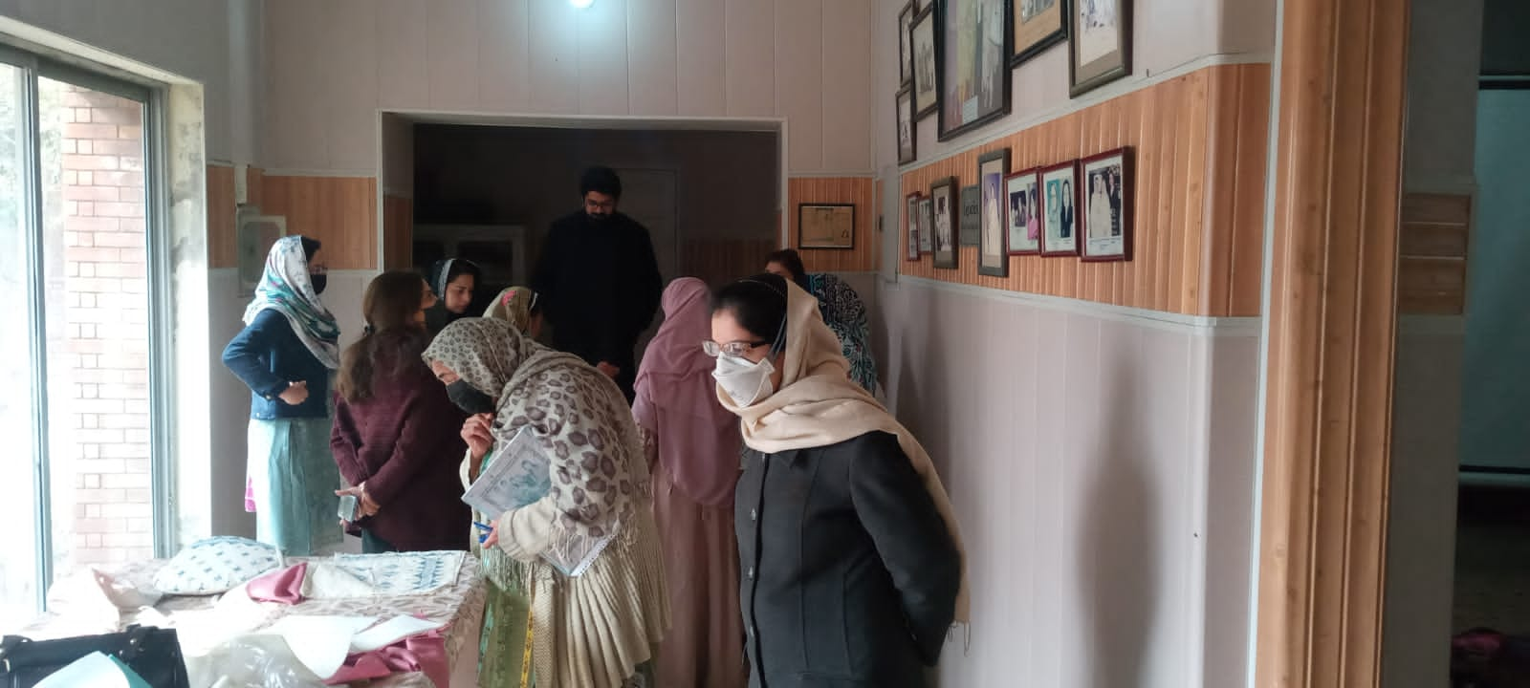

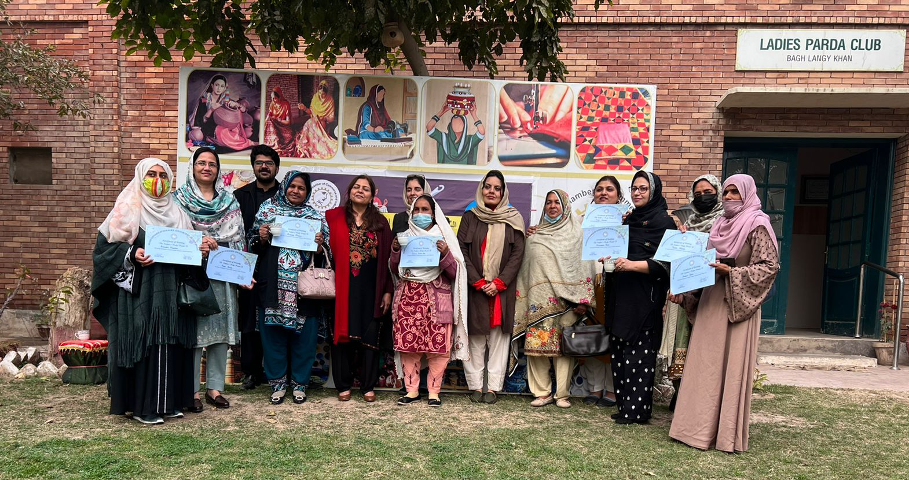

GOOGLE DRIVE LINK FOR Images / Assessment Form / Evaluation Form;
https://drive.google.com/drive/folders/1eayb5ja-CZ0KVaxKP5p0-q-nkUCaphbZ?usp=sharing

