MEETING WITH MR. ALI HAMDANI (M/S LANDMARK PAKISTAN), DATED NOV 17, 2020, AS PART OF PRELIMINARY STAKEHOLDER CONSULTATION FOR CONCEPT DEVELOPMENT OF “PAKISTAN VIRTUAL TOURISM EXHIBITION-2021”
Director General TDAP Islamabad put forth the proposed mega event (i.e. Pakistan Virtual Tourism Exhibition -2021) for discussion, in order to fine tune the concept with respect to user friendly interface, as well as effective targeting of the potential services export markets. Mr. Hamdani apprised the DG TDAP of their experience and model for tourism exhibitions. It was agreed that a subsequent meeting to be held to finalize the details of the concept, as well as its marketing strategies.

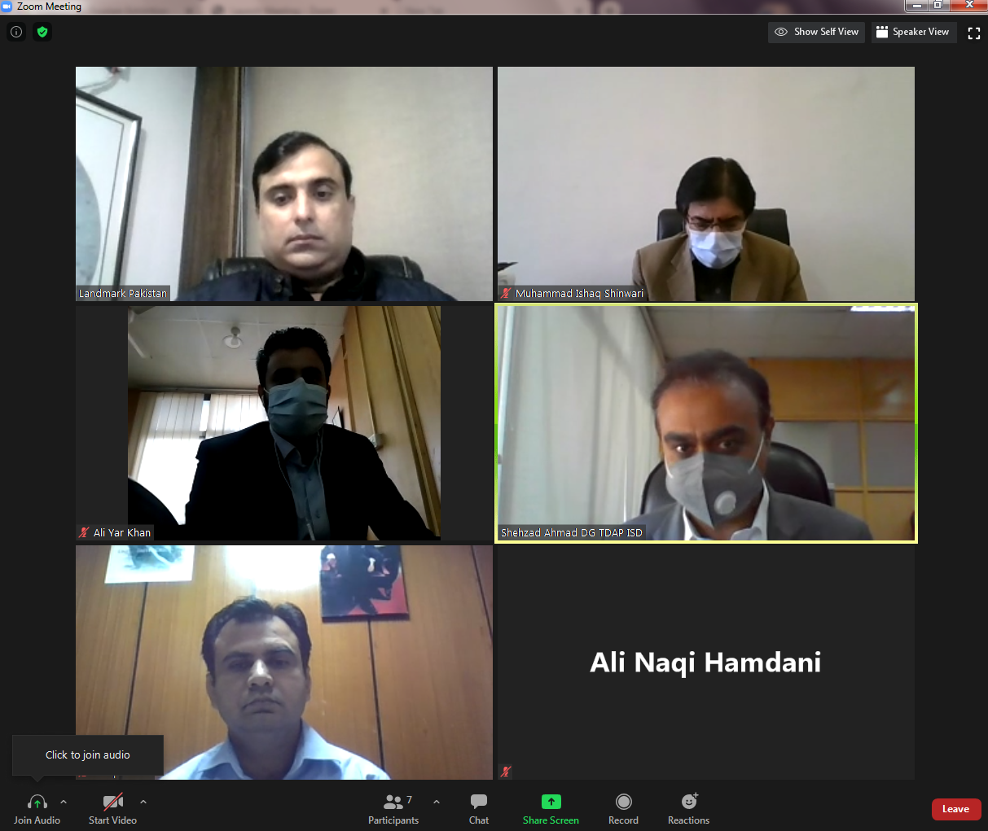

(ALI YAR KHAN)
Assistant Director
TDAP, Islamabad

