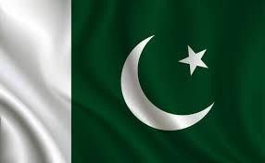

REPORT ON
“PAKISTAN-TAJIKISTAN BUSINESS FORUM & B2B SESSION ”

14th – 18th September, 2021

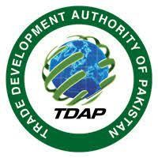

Table of Contents
1. Introduction 4
I. Preamble 4
a. Tajikistan Trade Profile 5
b. Pakistan – Tajikistan Trade Overview 6
c. Potential Sectors of Exports 6
d. Potential Sectors for JVs 7
e. Imports from Tajikistan for cost effectiveness 8
II. Objectives of Pakistan Tajikistan Business Forum 8
2. Pre-event activities 9
I. Budget Approval 9
II. Venue Management 9
III. Products in focus & preparation of delegates list 9
IV. Facilitation of Delegates 9
a. Air ticket: 9
b. Visa facilitation: 9
c. Hotel facilitation: 9
V. Design & printing 10
3. Pakistan Tajikistan Business Forum (Dushanbe, September 16th) 11
I. Venue 11
II. B2B Session 11
a. Leading sectors participating in B2B session 11
b. Summary of B2B meetings between Pakistani and Tajik Businessmen 13
c. Feedback of Pakistani Companies attending Business Forum And SWOT analysis of major Sectors 13
d. Business highlights 22
e. Testimonials of Pakistani Delegates 22
III. Pakistan – Tajikistan Business Forum – Conference (16th September, 2021) 23
a. Program of Conference 23
b. Summary of Business Forum-Conference 23
c. Distribution of Promotional Material 24
d. Status of MOUs/Contracts signed 24
4. Sideline Activities 26
I. Visits to Textile and Leather factories 26
II. Meeting with the Tajikistan’s Ministry of Industries 26
5. Management Teams 27
I. TDAP Facilitation Team 27
II. TDAP B2B Team 27
III. Transportation Team 28
6. Suggestions by delegations and Learnings / Recommendation 29
I. Suggestions by Delegations 29
II. Learning / Recommendations 29
7. Conclusion 30
8. Follow-up 31
9. Annexures 32
I. List of Pakistani Delegates 32
II. List of Tajikistan Delegates 36

Introduction

Preamble
Tajikistan is a mountainous landlocked country with a total area of 142,550 km2. It has common borders with other Central Asian Republics, including Kyrgyzstan and Uzbekistan, and with China, and Afghanistan. Its GDP stands at USD 8.19 bn (2020) with agriculture, mining, metal processing and services as the major contributors of the economy. With a population of 9.5 mn people, its per capita income is USD 1147, GDP per capita (PPP) is USD 3657.
Pakistan and Tajikistan share friendly relations. They are separated by a narrow strip of border called the Wakhan border and share close resemblance in their cultures, due to geographic proximity as well as common religion. Pakistan provides a potential transit route for Tajikistan to Arabian Sea and beyond, and also the shortest route. Moreover, Tajikistan is the entrance point for Pakistan into Central Asia and beyond towards Eastern Europe. Hence, both countries can find many opportunities in terms of economic and trade relationships.
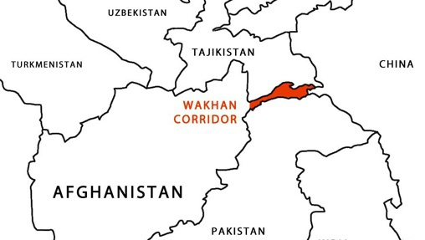
Currently, Pakistan and Tajikistan do not have any trade agreement, however they can find trade opportunities in many sectors, including logistics, pharmaceuticals, agriculture and textile. Pakistan as the transit route for Tajikistan, has great potential in transport and logistic sector, providing an open field to bring in road shipping lines and building a competitive environment with better and efficient transit cargo services. Moreover, with cotton and yarn as one of the major exports of Tajikistan, textile sector offers an opportunity for joint ventures between the two countries, where Pakistan can provide its expertise in fashion industry and finished textile products. Pharmaceuticals is one of the major imports of Tajikistan, and Pakistan can explore it as an export market. Furthermore, as agriculture is one of the major contributors of Tajik economy, avenues for joint ventures, and opportunities for bilateral trade can be explored between the two countries.
Though, Tajikistan is a very small country in terms of population and GDP, however, it can be used as the starting point for Pakistan to enter the Central Asian Republics and Eastern Europe and explore the untapped markets for Pakistani products.

Tajikistan Trade Profile
Following tables explain the trade profile of Tajikistan.
Year | 2016 | 2017 | 2018 | 2019 | 2020
Imports of Tajikistan | 3031463 | 2774436 | 3144346 | 3327744 | 3139016
Exports of Tajikistan | 899320 | 983826 | 1073858 | 1115850 | 1311879
Unit : US Dollar thousand
Source: TradeMap

Sr. No. | Tajik Export Market, 2020 | Tajik import Market, 2020 | Major Imports, 2020 |  | Major Exports, 2020
 |  |  | HS Code | Description | HS Code | Description
1 | Switzerland | Russian Federation | '27 | Mineral fuels, mineral oils and products of their distillation; bituminous substances; mineral waxes | 71 | Natural or cultured pearls, precious or semi-precious stones, precious metals, metals clad with precious metal, and articles thereof; imitation jewellery; coin
2 | Turkey | Kazakhstan | '10 | Cereals | '52 | Cotton
3 | Kazakhstan | China | '72 | Iron and steel | '26 | Ores, slag and ash
4 | Uzbekistan | Uzbekistan | '84 | Machinery, mechanical appliances, nuclear reactors, boilers; parts thereof | '76 | Aluminium and articles thereof
5 | Afghanistan | Turkey | '87 | Vehicles other than railway or tramway rolling stock, and parts and accessories thereof | '25 | Salt; sulphur; earths and stone; plastering materials, lime and cement
6 | Russian Federation | Germany | '85 | Electrical machinery and equipment and parts thereof; sound recorders and reproducers, television image and sound recorders and reproducers, and parts and accessories of such articles | '27 | Mineral fuels, mineral oils and products of their distillation; bituminous substances; mineral waxes
7 | China | Korea, Republic of | '44 | Wood and articles of wood; wood charcoal | '81 | Other base metals; cermets; articles thereof
8 | Belgium | Belarus | '15 | Animal or vegetable fats and oils and their cleavage products; prepared edible fats; animal or vegetable waxes | '62 | Articles of apparel and clothing accessories, not knitted or crocheted
9 | Italy | Iran, Islamic Republic of | '28 | Inorganic chemicals; organic or inorganic compounds of precious metals, of rare-earth metals, of radioactive elements or of isotopes | '72 | Iron and steel
10 | Pakistan | Japan | '39 | Plastics and articles thereof | '08 | Edible fruit and nuts; peel of citrus fruit or melons
Source: TradeMap

Pakistan – Tajikistan Trade Overview
Following graph explains the trend of Imports and Exports of Pakistan to Tajikistan in the last five years.

Source: TradeMap

Potential Sectors of Exports
As per trade statistical analysis done on the basis of data from the Trade Map, pharmaceutical, food, and textile have come up as potential sectors of exports for Pakistan to Tajikistan. At the start of the activity, the mission in Dushanbe identified these same sectors along with logistics and mining as potential ones. Following graph explains Tajikistan’s imports from the world and Pakistan’s exports to the world in these potential sectors.

Source: TradeMap

Potential Sectors for JVs
As per the mission and after analyzing the ground realities, it has been found that there is a potential for Joint Ventures between Pakistan and Tajikistan in the following four sectors.
- Food Sector
- Installation of Processing Plants.
- Establishment of Cold storage chains.
- Textile Sector
- Establishment of vocational training institutes.
- Up-gradation of Tajik textile sector.
- Mining Sector
- Assistance in mining machinery and implements.
- Provision of labor force.
- Tourism Sector
- Developments of tourist sites in both countries.

Imports from Tajikistan for cost effectiveness
Pakistan imports many raw materials for the preparation of finished products that it ultimately exports. Pakistan imports raw cotton from the USA, Brazil, Mexico, Argentina and unwrought Aluminum from Saudi Arabia, UAE and China. However, these two items are among the top exports of Tajikistan. Following graph categorically explains it.

Source: TradeMap

Objectives of Pakistan Tajikistan Business Forum
Followings were the main objectives of the event:
- To explore Central Asian Markets, in general, and Tajikistan in particular as new export avenues for Pakistan.
- To facilitate Pakistani Business community to find new business and investment opportunities in Tajikistan.
- To provide a platform for JVs between Pakistani and Tajik Business community.

Pre-event activities

Budget Approval
The budget for the event was prepared and rationalized by TDAP ISD and after consent from
TDAP HQs, it was approved by EDF.

Venue Management
Venue for the Business Forum was selected and managed by Tajikistan Government.

Products in focus & preparation of delegates list
The sectors & sub-sectors were identified by the mission in Dushanbe, as well as Product divisions of TDAP. Besides this Ministry of Commerce also identified potential companies for incorporation in the delegation. (The final list has been attached in annexure).

Facilitation of Delegates
The facilitation to delegates was extended in the following areas:

Air ticket:
There was no direct flight from Islamabad to Dushanbe. The delegates had two options, either to travel by commercial flight or via charter flight arranged by TDAP. Considering time constraints and travelling issues, PIA charter flight was arranged by TDAP. Once the flight was arranged, TDAP managed all the payment receipts and coordinated with PIA for ticketing process. The tickets were shared with all delegates before departure.

Visa facilitation:
TDAP collected details of passports for Note-verbale (NV) of all the delegates to get visa which were then sent to Ministry of Commerce for issuance of NV to Tajikistan Embassy. Coordination was carried out with Tajik Embassy in ISD so as timely visas were issued. Other than that, all the delegates were communicated information regarding visa application process. Moreover, all the passports were collected by TDAP, submitted in Tajik Embassy and sent back to some delegates via courier after the visa endorsements. A few delegates also collected their passport at the airport from facilitation desk established by TDAP Islamabad.

Hotel facilitation:
Trade Mission shared a list of two hotels with TDAP which were shared with the delegates to book their hotel as per their choice and convenience.

Design & printing
- Designing of logo, theme, backdrops, and standees etc. and printing of B2B proforma was done by TDAP and shared with the Mission.
- A comprehensive booklet (in English as well as translated in Russian) showcasing major trade statistics and highlights of Pakistani foreign trade, investment and connectivity was developed keeping in view the products in focus. 200 copies of the booklets were printed and distributed later on among the Tajik delegates during the Conference and B2B session.
- A detailed directory of Pakistani delegates (in English as well as translated in Russian) was developed for information sharing with Tajik counterparts. 200 copies of the directories were printed and distributed later on among the Tajik companies during the Conference and B2B session.

Pakistan Tajikistan Business Forum (Dushanbe, September 16th)

Venue
Ministry of Commerce and Trade Development Authority of Pakistan organized Pak-Tajik
Business Forum on 16th September, 2021 at Hyatt Regency, Dushanbe.
The event was divided into two main components:
- B2B Meetings - interactions of Pakistani delegates with Tajik buyers through dedicated collaborative endeavors (16th September, 2021)
- Pakistan-Tajikistan Business Forum-Conference (16th September, 2021)

B2B Session
There was a B2B matchmaking exercise between the businessmen of both countries on 16th September, 2021 before the Conference. The successful execution of B2B interaction was a result of well-planned and well-coordinated efforts of TDAP team and Commercial section of the Pakistan’s mission in Tajikistan.

Leading sectors participating in B2B session
TDAP arranged business delegation comprising of 58 Pakistani companies including leading business representatives from textile, fruit and vegetables, pharmaceuticals, tourism, construction, mining, and logistics, etc. Moreover, representatives from leading trade bodies such as FPCCI, QCCI, CCCI and SCCI were part of the Pakistani delegation.
List of sectors from Pakistani side
Sector | No of Exporters
Transport and Logistics | 11
Pharmaceutical | 12
Food sector | 8
Tourism | 2
Textile | 9
Leather | 2
Mining | 4
Fans and Home Appliances | 1
Construction | 2
Handicraft | 1
Trading | 1
Others | 5
Total Pakistani Exporters | 58

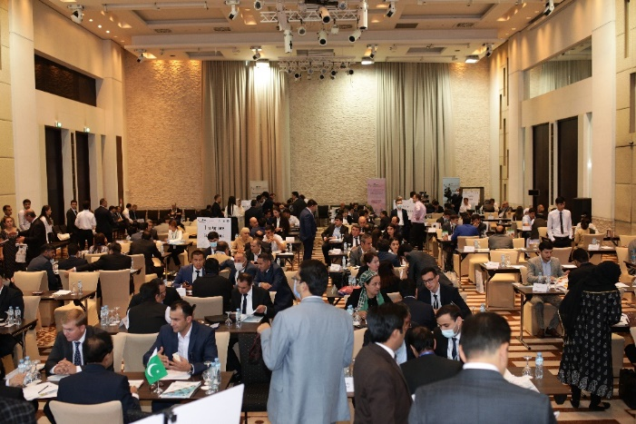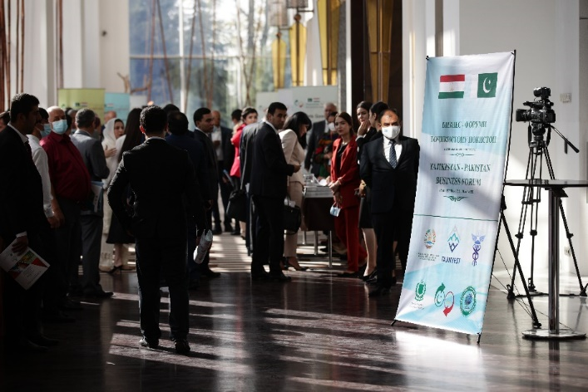
The list of 248 Tajik businessmen was shared by Trade Mission (enclosed in annexure). The product officers were designated to prepare B2B schedules for their allocated sectors which were shared with all Pakistani delegates before departure. Also those sectors were identified where Pakistani delegates or Tajik buyers were not available for B2B interactions. The details of the Tajik buyers is reported in the table below. The registration process for Tajik companies was done by the mission staff. Name Tags were distributed among the Pakistani delegates by the Product Officers from TDAP.
List of sectors from Tajikistan side
Sector | No of Exporters
Transport and Logistics | 23
Pharmaceutical | 44
Food sector | 44
Tourism | 43
Textile | 47
Leather | 7
Mining | 16
Fans and Home Appliances | 3
Construction | 5
Handicraft | 3
Trading | 2
Others | 11
Total Tajikistan Importers | 248

Summary of B2B meetings between Pakistani and Tajik Businessmen
The response from both Tajik and Pakistani sides was encouraging as out of 248 delegates list shared by Trade Mission (Dushanbe) approximately 116 Tajik buyers attended the Business Forum. More than 800 business interactions took place between Pakistani exporters and Tajik buyers. Mission shared that the reason for companies who could not join was road blockages and diversions of traffic due to VVIP movements of SCO summit.
In addition to that, Pakistan’s pharmaceutical, fruit and vegetable, textile, logistics, mining, construction companies also signed different agreements and MOUs related to trade, investment and joint ventures.
Following sectoral B2B meetings were held during Business Forum.

Sr. No. | Sectors | Pakistan Delegates | Tajik importers | No. of scheduled B2B meetings | Tajik companies showed up | Actual B2B interactions
1 | Transport and Logistics | 11 | 23 | 253 | 15 | 165
2 | Pharmaceutical | 12 | 44 | 528 | 18 | 216
3 | Food sector | 8 | 44 | 352 | 12 | 96
4 | Tourism | 2 | 43 | 86 | 6 | 12
5 | Textile | 9 | 47 | 423 | 21 | 189
6 | Leather | 2 | 7 | 14 | 5 | 10
7 | Mining | 4 | 16 | 64 | 10 | 40
8 | Fans and Home Appliances | 1 | 3 | 3 | 5 | 5
9 | Construction | 2 | 5 | 10 | 6 | 12
10 | Handicraft | 1 | 3 | 3 | 1 | 1
11 | Trading | 1 | 2 | 2 | 2 | 2
12 | Others | 5 | 11 | 55 | 15 | 75
 | Total | 58 | 248 | 1793 | 116 | 823

Feedback of Pakistani Companies attending Business Forum And SWOT analysis of major Sectors

As per the feedback proforma shared with delegates during B2B meetings, following feedbacks were received.

Pharmaceutical Sector:
Sr. No. | Name of Company | Delegate Name | Feedback
1 | Fedro Pharma | Junaid Altaf | Very fruitful meeting. I want to shift my plant here in Tajikistan
2 | Bio Labs Pharma | Usman Shaukat | Product list to be revised. Only few pharma companies have showed up today.
3 | Zafa Pharmaceutical | Dr Syed Qamar Ali | It is a good initiative by TDAP, MoC and Mission. Omer Bajwa has been very helpful.
4 | Davis Pharma | Amanullah Sheikh | Satisfied with the arrangements done by government.
5 | CCL Pharma | Syed Umair Maroof | Very fruitful interaction with Tajik Side.
6 | SANTE Pharmaceutical | Tauqeer-ul-Haq | It was a productive session.
7 | Maxitech Pharma | Nadir Hassan Khan | Overall organized very well. TDAP Miss Shumaila and Omer Bajwa well done. Other members of TDAP also good job.
8 | Focus and Rulz pharma | Fazli Hanan | Good job. Follow-up will define future course
9 | Friends pharmaceutical | Moh Talal Saleem | Overall experience is good.

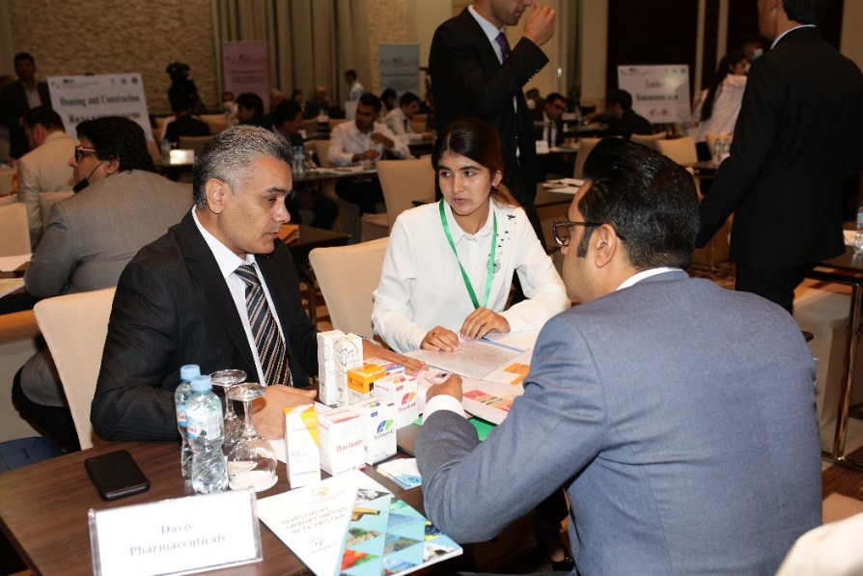
SWOT Analysis:
Strengths
- 95 % of the total pharmaceutical demand is covered through imports.
- Huge demand of pharmaceutical products manufactured in Pakistan. For instance, products related to diabetes, blood purifier, disposable syringes and allergy.
Weaknesses
- Absence of transit trade agreement between Tajikistan, Afghanistan.
- Absence of direct cargo flights to Tajikistan.
- Absence of easy visa regime for foreign businessmen.
- Absence of banking channels for monetary transactions between business parties.
Opportunities
- Cost effective and less time consuming land route to Tajikistan for transportation of perishable products once logistics and transit trade agreement is in place.
- TIR convention between the two countries can further enhance and ease the trade.
- Trade to Tajikistan will open Eurasian region for Pakistani products.
Threats
- Loss of revenue/ foreign exchange due to absence of transit agreement between Pakistan and Tajikistan.
- Loss of origin identity of Pakistani products due to their exports under Afghanistan’s customs.
- Non existing banking channels create opportunities for fraudulent activities and undocumented economic activities.

Mining Sector:
Sr. No. | Name of Company | Delegate Name | Feedback
1 | Coal and Minerals | Sardar Yahya Khan Nasir | It was a very good forum and we exchange our business ideas with Tajik side.
2 | Wah Nobel Group | Brg. Shirazullah Ch | Excellent forum and we negotiated import of aluminum from Tylco and export of chemicals from Pakistan
3 | Abdul Sattar Nasar and sons | Abdul Aziz Nasar | It was good. IA in future it will yield good results.
4 | Al Rehman Coal Company | Mir Bahrose Hussain | Excellent. Business generation is expected.

SWOT Analysis:
Strengths
- Tajikistan is a mountainous – landlocked country. Pakistan can be the best route for Tajikistan to export its minerals.
- Aluminum ore is one of the major exports of Tajikistan.
- Availability of Tajik Coal will provide Pakistani industries a cost effective alternative for energy generation.
Weaknesses
- Absence of transit trade agreement between Tajikistan, Afghanistan, and Pakistan.
- Absence of direct cargo flights to Tajikistan.
- Absence of easy visa regime for foreign businessmen.
- Absence of banking channels for monetary transactions between business parties.
Opportunities
- Cost effective and less time consuming land route to Tajikistan for transportation of products once logistics and transit trade agreement is in place.
- There is growing demand of Aluminum in Pakistan’s fan, cutlery and auto parts industry.
- TIR convention between the two countries can further enhance and ease the trade.
Threats
- Loss of revenue/ foreign exchange due to absence of transit agreement between Pakistan and Tajikistan.
- Loss of origin identity of Pakistani products due to their exports under Afghanistan’s customs.
- Non existing banking channels create opportunities for fraudulent activities and undocumented economic activities.
- Volatile situation of Afghanistan.

Textile Sector:
Sr. No. | Name of Company | Delegate Name | Feedback
1 | Tania Collection | Talat Hafeez Khan | Thanks for the fantastic business event organized by TDAP and mission. I made good contacts. Will follow up that. It’s all because of amazing hard work and dedication by officers
2 | Sapphire Group | Tahir Mehmood Khan | I highly appreciate your efforts to successfully execute such a mega event. Congratulate to the entire TDAP team and the mission.
3 | Afroze Textle | Bilal Alam Lari | The event was organized but couldn’t make much out of it because Tajik textile sector is at developing stage. Good effort on the part of Ali Raza.
4 | Royal textile | Zahid Shah | This was a wonderful event arranged by MoC and mission. The TDAP guys (Ali, Umer, Khushbakht) were very helpful and cooperative. This type of event should be arranged to promote trade with other neighboring countries.
5 | Mushtaq Najeeb Traders | Mushtaq Najeeb Vohra | Very good initiative and very good organization of the event. Well done Pakistan embassy and trade mission in Dushanbe.
6 | Gohar Textile | Gohar Mustafa | Excellent effort team TDAP and mission.

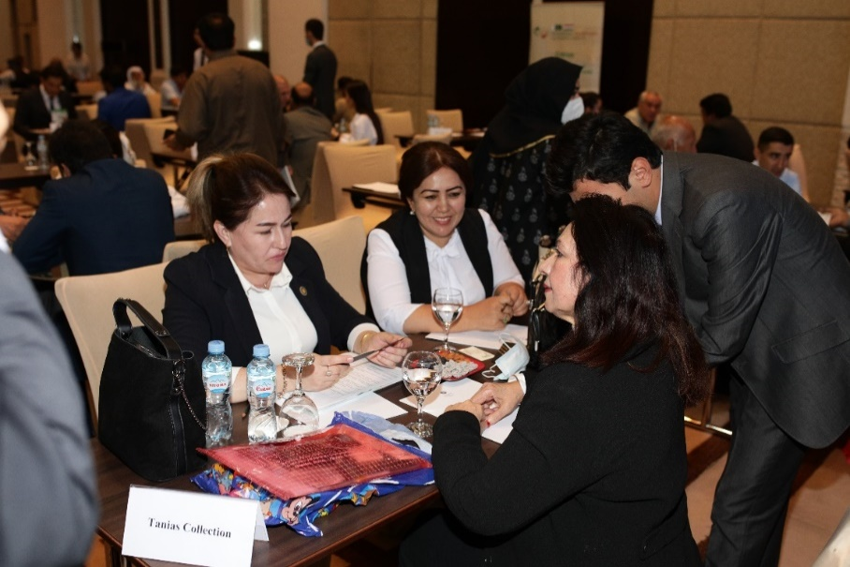
SWOT Analysis:
Strengths
- Tajikistan is an agrarian economy. They are producing cotton more than their local consumption.
- Tajikistan as a gateway to other Central Asian Republics and Eastern Europe. Pakistan can boost its textile export by entering into these markets.
- They are exporting cotton and yarn to the world at competitive prices.
Weaknesses
- No transit trade agreement between Tajikistan, Afghanistan, and Pakistan; hence E-form is not issued for exports to Tajikistan via Afghanistan land route.
- Absence of direct cargo flights to Tajikistan.
- Absence of easy visa regime for foreign businessmen.
- No Banking channels for monetary transactions between business parties.
Opportunities
- The weather pattern of two countries is very much same. Pakistan can launch its medium and high end brands into Tajikistan.
- Raw cotton and yarn can be imported into Pakistan at lower price.
- People follow same dress pattern in both countries with a slight change. Pakistan’s fashion designer can easily tap this market.
- Joint ventures can be made with Tajik companies to operate their closed units.
- Employment opportunity is also there in textile sector. Most of the operating units are working at under capacity.
- TIR convention between the two countries can further enhance and ease the trade.
- Cost effective and less time consuming land route to Tajikistan for transportation of perishable products once logistics and transit trade agreement is in place.
Threats
- Loss of revenue/ foreign exchange due to absence of transit agreement between Pakistan and Tajikistan.
- Loss of origin identity of Pakistani products due to their exports under Afghanistan’s customs.
- Non existing banking channels creates opportunities for fraudulent activities and undocumented economic activities.

Leather Sector:
Sr. No. | Name of Company | Delegate Name | Feedback
1 | Askari Shoes | Kamran Aslam | Excellent arrangements by TDAP, MoC, Mission
2 | Kumail Gloves Industries | Qamar Munir | Impressed by the arrangements done by mission and TDAP officers. Good work

Food Sector:
Sr. No. | Name of company | Delegate Name | Feedback
1 | M/sFruiti Fresh Pvt.Ltd | Saqib Rauf | It was Good. Awaiting for the result. When TIR will start in our sector. Hopping to get good results.
2 | Roshan traders | Khalid Ejaz | Need road link for smooth business.
3 | Kakar Traders | Muhammad Akhtar Khakar | Excellent arrangement. Such delegations should be arranged. Baluchistan should be included. TDAP has worked wonderfully. Khushbakht, Ali , Omer did a great job.
4 | Iftekhar Ahmed & Co | Waheed Ahmed | Need more focus on industry of beverages and super stores.
5 | Aryana Company | Abdur Rahim | Excellent work
6 | Fresh Fru | Muhammad Shehzad Sheikh | Nice arrangement by TDAP. Good work done by Kushbakht Asif.
7 | Al- Rafique Enterprises | Muhammad Riaz | Transportation and payment should be the addressing issues.

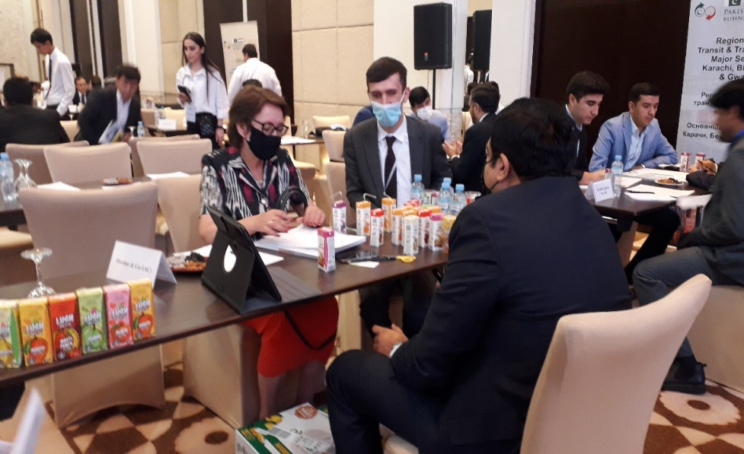
SWOT analysis:
Strengths
- Mangoes and Mandarins (citrus products) are not produce in Tajikistan, but are highly demanded by the locals.
- Potatoes are one of the major vegetables imported by Tajikistan, and major vegetable exported from Pakistan.
- Comparatively better food processing industry of Pakistan.
Weaknesses
- No transit trade agreement between Tajikistan, Afghanistan, and Pakistan; hence E-form is not issued for exports to Tajikistan via Afghanistan land route.
- Absence of direct cargo flights to Tajikistan.
- Absence of easy visa regime for foreign businessmen.
- No Banking channels for monetary transactions between business parties.
- Absence of Reefer trucks for transportation of perishable food items.
Opportunities
- Demand for Pakistani Fruits and Vegetables, especially Kinnow, Mango, and Potato.
- Demand for packaged foods, such as fruit beverages, dairy cream, milk, etc. for the retail sector.
- Demand for edible vegetable oils, and seed oils.
- Cost effective and less time consuming land route to Tajikistan for transportation of perishable products once logistics and transit trade agreement is in place.
- TIR convention between the two countries can further enhance and ease the trade.

Threats
- Loss of revenue/ foreign exchange due to absence of transit agreement between Pakistan and Tajikistan.
- Loss of origin identity of Pakistani products due to their exports under Afghanistan’s customs.
- Non existing banking channels create opportunities for fraudulent activities and undocumented economic activities.

Transport and Logistics Sector:

Sr. No. | Name of Company | Delegate Name | Feedback
1 | Natonal Logistics cell | Usman Mansoor | Tajik partners are reluctant to commit anything due to afghan situation in coming days. However they are eager to boost trade with Pakistan.
2 | Yaseen Transport Co(Pvt) Ltd. | Mr. Fojan | The meeting was very fruitful. I found an importer who was interested to import 100 tons of some herb of medicinal value. Business generated from this is exceptional.
3 | Pyramid Logistics | Mr. Yaqoob Sheikh | We must tap markets of CAR's.
4 | Best trans Private limited | Ramiz Ali Rabbani | MoC should continue such events in Europe also.
5 | MM Elahi Traders | Manzoor sheikh Elahi | Transit agreement needed.

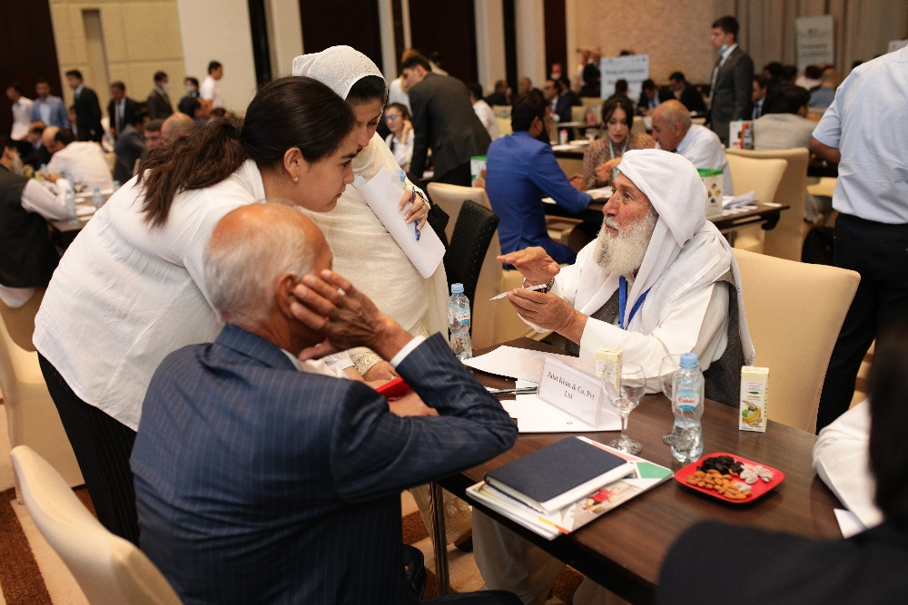

SWOT Analysis:
Strengths
- Pakistan offers shortest transit land route to deep water sea port for Tajikistan and other Central Asian Republics.
- Tajikistan as a gateway to other Central Asian Republics and East Europe for trade through land routes.
Weaknesses
- Non-inclusion of Tajikistan under WeBOC module for transit trade from Pakistan via Afghanistan.
- No Banking channels for monetary transactions between business parties.
- Logistic services being provided under Afghani consignee due to absence of transit agreement.
Opportunities
- High demand for the logistic services as CPEC connects Central Asia to Pakistan’s sea ports.
- Creation of employment and job opportunities once logistics services are streamlined.
- Cost effective and competitive logistic services due to high potential for investments.
Threats
- Loss of revenue/ foreign exchange due to absence of transit agreement between Pakistan and Tajikistan.
- Loss of origin identity of Pakistani products due to their exports under Afghanistan’s customs.
- Non existing banking channels create opportunities for fraudulent activities and undocumented economic activities.
- Loss of potential investment in the sector due to absence of transit trade agreement and Afghanistan’s volatile political situation.

Construction Sector:
Sr. No. | Name of company | Delegate name | Feedback
1 | AIMTECH Builders | Maj. Abdul shahkoor Shab | Joint Business council carried out in excellent manner. Arrangement and coordination was done marvelously by Ali Raza
2 | Kingdom Valley | Gulam Hussain Shahid | Good work

Business highlights
- More than 800 business meetings took place and approximately US$ 20 million agreements/deals were signed during the event. Other discussions are going on to finalize business deals.
- 16 MOUs were signed on 16th September, 2021. Other business deals are in process of finalization.

Testimonials of Pakistani Delegates
Sr. No. | Company | Testimonial
1 | President APMMA | I would like to thank the entire team of, TDAP, for arranging such a wonderful and fruitful Trip to Tajikistan. We can work in future together for many great opportunities. And please do let us know for any future upcoming delegation. I would once again thank TDAP And specially BAJWA Saab For his lovely hospitality for us .
2 | CCL Pharma | Please accept our sincere gratitude on arranging a mission of such high potential market. We all need to take this as stepping stone and foundation is laid down. Now in my humble opinion following could be the way forward: 1- Industry specific targets need to be set for exports: Like Taj Pharma market is of 250M $ which is 95% dependent on exports, now we need to set 3- and 5-years plan that how much market share we can capture from this. 2- And more importantly what would be the role of Embassy, Pharmaceutical companies and TDAP in achieving above target. Otherwise, if certain financial objectives won’t be achieved, then these type of events will eventually lose its importance. In the end, Mr. Bajwa & TDAP team a lot of power and prayers to you.
3 | Davis Pharmaceutucals | Mr Omer Bajwa and team with pleasure I would like to express my gratitude for organizing such a successful event in Tajikistan which was well coordinated and adequately arranged specifically the arrangement of B2B meetings was extraordinary and precise, you did your part well and now it’s our turn to take benefit of that and grab some foreign exchange for the state so acknowledging your work I must appreciate you, your team and the staff of Pakistan embassy in Dushanbe for arranging an effective event ….. Well done keep it up you all deserve accolade !!!
4 | Royal Textile | This was a wonderful event arranged by MoC and mission. The TDAP guys (Ali, Umer, Khushbakht) were very helpful and cooperative. This type of event should be arranged to promote trade with other neighboring countries.
5 | Mushtaq Najeeb Vohra (Trader) | Very good initiative and very good organization of the event. Well done Pakistan embassy and trade mission in Dushanbe.
6 | Focus & Rulz pharmaceuticals | Salam to all it was a wonderful trip The best part was to meet good people from Pakistan both private sector and government officials I think we should have more of such meetings and delegations because I have been in export and it is not a one day match but a test match and needs long term consistency
7 | National Logistics Cells | Tajik partners are reluctant to commit anything due to uncertain Afghan transit forecast in coming weeks. However, they are eager and interested to boost transit trade and bilateral trade with Pakistan and established contacts for future usage.
8 | Pyramid Logistics | A good initiative. We must tap markets of CARs.
9 | Best Transports | Government should continue such events in Europe also.
10 | Maxitech Pharma | Alhumdulilah it was worthy trip in terms of event management that was properly done by TDAP & really thankful to Ministry of commerce especially Ma'am Maria Qazi for deep analysis. We will definitely work as a key player in such markets & generate foreign exchange. Hoping continuation of such valuable events in future for Pakistan industry.
11 | Iftekhar & Co. | Need more focus on industries of beverages and super stores.
12 | Al-Rafique Enterprises | Such delegations should be formed in the future as well where facilitations are provided for air traveling, accommodations, B2B sessions, it saves time and energy of the business men. 2-3 extra days are suggested for follow-up meetings after B2B.
 |  | Moreover, Government needs to work on establishing transportations lines via road (better connectivity) and payment arrangements should be established through formal banking channels.
 |  | Connectivity can be improved through introducing Pakistan China Shipping Corporation, Reefer trucks under TIR convention, trade in Pakistani Rupee and Tajik Somoni, etc.
13 | Tania Collection | Thanks for the fantastic business event organized by TDAP and mission. I made good contacts. Will follow up that. It’s all because of amazing hard work and dedication by officers.
14 | Sapphire Group | I highly appreciate your efforts to successfully execute such a mega event. Congratulate to the entire TDAP team and the mission.
15 | Askari Shoes | Responsibility of MoC/TDAP is to arrange such events in terms of conceptual Dynamics with the Other country, Logistics of move of Delegates and of B2B meetings. I think MoC/TDAP has done their best. Rest is destiny, and how delegates understand Dynamics and operate with Patience. ..As our Honorable Prime Minister said here that “hiccups are known on both sides, perseverance will lead us to PTA”.

Pakistan – Tajikistan Business Forum – Conference (16th September, 2021)

Program of Conference
- Registration of participants.
- Speech by the Deputy Prime Minister of Republic of Tajikistan
- Speech by the Adviser to the Prime Minister on Commerce and Investment of the Islamic Republic of Pakistan Mr. Abdul Razak Dawood
- Presentation by Mr. Jamil Qureshi, Director General (Investment Promotion) Board of Investment, Government of Pakistan.
- Signing ceremony of MOUs.
- Speech by the Prime Minister of Islamic Republic of Pakistan H.E Mr. Imran Khan.
- Q&A session.
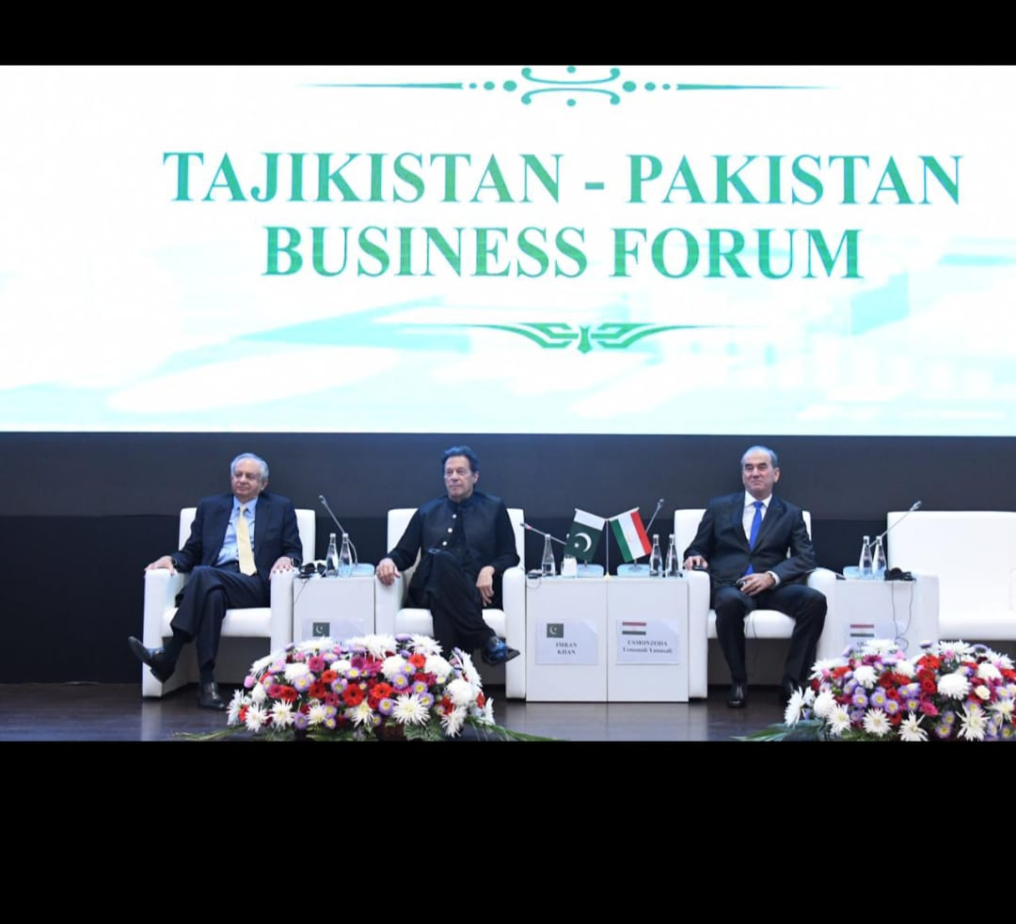

Summary of Business Forum-Conference
Pakistan-Tajikistan Business Forum- Conference started with a welcome note from Tajik host, followed by a speech from Advisor to PM on Commerce and Investment, Mr. Razzak Dawood, endorsing economic integration of Pakistan and Tajikistan as a step towards regional integration and creation of a Win-Win situation for both countries. The speech of Mr. Dawood was followed by a presentation by BOI representative, who highlighted the potential sectors of Pakistan for investments, as well as joint ventures between the two countries.
After BOI’s presentation, Deputy Prime Minister of Republic of Tajikistan gave a presentation on Trade and Economy of Tajikistan, identifying potential sectors where Pakistan can find opportunities for trade and economic partnership. Following this speech was the MoU signing ceremony between Pakistan and Tajik Companies.
The Honorable Prime Minister of Islamic Republic of Pakistan, Mr. Imran Khan arrived at the venue after the signing of MoUs, and gave an elaborate speech on the economic cooperation between the two countries and facilitation of business delegates from both sides to enhance their bilateral trade.
The PM’s speech was followed by a Question & Answer session, where business men from both sides expressed their gratitude and highlighted the current issues and challenges for trade between Pakistan and Tajikistan which needs to be addressed.

Distribution of Promotional Material
Promotional material developed by TDAP was distributed among the Tajik delegates. Following items were included in the promotional material
- Pakistan-Tajikistan Trade potential booklet
- Delegates Directory

Status of MOUs/Contracts signed
Several MOUs and contracts were signed and exchanged among the business delegates from Pakistan and Tajik side during the conference. These include MOUs/ contracts in the fields of pharmaceutical, mining, construction, food, textile, and logistics.
Sr. No. | Sector | Pakistan Company | Tajikistan Company | Type of Contract | Scope of MOU
1 | Pharmaceutical | Taqwa Pharmaceutical and Surgical | Aziz & Co. Tajikistan | MOU | Current Business is 100K and expected to increase up to 300K.
2 | Pharmaceutical | Zafa Pharmaceuticals Laboratories Pvt. Ltd | Aziz & Co. Tajikistan | MOU | Currently it has 150-200k USD Business, now, expecting 0.5 mn to 1 mn USD in next 3 years.
3 | Logistics | MM Elahi Traders | Avid LLC/ Mr. Muhammad | Contract under process | Import of fruit juices of about 300-400 tons per month.
4 | Logistics | MM Elahi Traders | Mohammad Sohaili | Contract | Import from Pakistan approx. 200 containers of potatoes and 300-400 containers of mandarin ( kinnows)
5 | Pharmaceutical | CCL Pharmaceuticals (Pvt.) Ltd. | Shifo Sino LLC | MOU | Expected rise in exports up to 0.5 million USD.
6 | Pharmaceutical | CCL Pharmaceuticals (Pvt.) Ltd. | Tib Baroi Shumo LLC | MOU | Expected rise in exports up to 0.5 million USD.
7 | Pharmaceutical | Marhaba Laboratories (Pvt.) Ltd. | OOO Khushbaktion | MOU | Strengthening of already established business.
8 | Pharmaceutical | Focus and Rulz Pharmaceuticals Pvt Ltd. | Doru Farms LLC | MOU | Expected rise in exports up to 0.5 million USD.
9 | Logistics | Pyramid Logistics | AVAS Group | Contract under process | Expected logistics service of USD 50000 per month.
10 | Logistics | Best Transports | UMID Trans logistics | Contract under process | 5 containers of 9 cubic meters per month.
11 | Logistics | Best Transports | Asia Trans | Contract under process | 5-6 containers of 9 cubic meters per month.
12 | Logistics | Banigala logistics | Avas Groups | MoU | Mutually agreed on granting of logistic support by Banigala to Avas Groups.
13 | Construction | Aimtech Builders Islamabad | Abdullah construction Dushanbe Tajikstan | MOU | 5 mn $ in times to come on new construction of multi storey buildings in KINGDOM VALLEY a project NAYA PAKISTAN
 |  |  |  |  | The company is interested to come over to Pak under 50/50 % partner in JV.
14 | Food | Al-Rafique Enterprises | Aushan | Contract | Expected exports of USD 1Mn.
15 | Food | Al-Rafique Enterprises | Mr. Yaqoob | Contract | Expected exports of USD 1Mn.
16 | Food | Al-Rafique Enterprises | Mr. Pervaizi | Contract | Expected exports of USD 1Mn.
17 | Food | Al-Rafique Enterprises | Mr. Faizullah | Contract | Expected exports of USD 1Mn.
18 | Food | Fresh Fru | AMID | Contract under process | Expected Exports of USD 40000 of Kinnow and mandarin
19 | Food | Iftekhar & Co. | Aushan | Contract under process | Expected exports of USD 50000
20 | Tourism | Haris Mehmood (Pvt.) Ltd. | Sahropov Sayfiddan | MOU | JV to promote tourism in both countries.
21 | Mining | Wah Nobel | Talco Company | MoU | Import of aluminum ore from Tajikistan
22 | Mining | Al-Rehman Coal company |  | Contract under process
23 | Mining | Haji Abdul Sattar Nassar & Sons | Talco Company | Contract under process | Exports of fluoride from Pakistan.
24 | Home Appliances | Pakistan Elektron Company Limited (PEL) | Tgen Company | Contract under process | Maturity of contract will bring USD 0.1-1 Mn within 2 years to Pakistan.
25 | Textile | Tania Collection |  | Contract under process | Expected export contract of USD 100,000 between them
26 | Textile | Sapphire Group | LLC Toj Tex | Contract under process
27 | Textile | Mushtaq Najeeb Vohra | Through brokers |  | Import of yarn into Pakistan ( 1 to 1.5 mn dollars monthly)
28 | Textile | Afroze Textile Mills | LLC Ganj | Contract under process

Sideline Activities

Visits to Textile and Leather factories
- Visit to textile and leather factories was arranged by the mission on 15th September, 2021. The purpose was primarily to give our textile and leather delegates an idea about Tajik textile sector.
- Visit of three textile factories (Vahdat textile, Toj textile, Ganj textile) and one leather factory (Poyafzoli charm) was arranged for the delegates.
- Response from delegates was good as this visit gave them an idea what they can trade with Tajik companies.
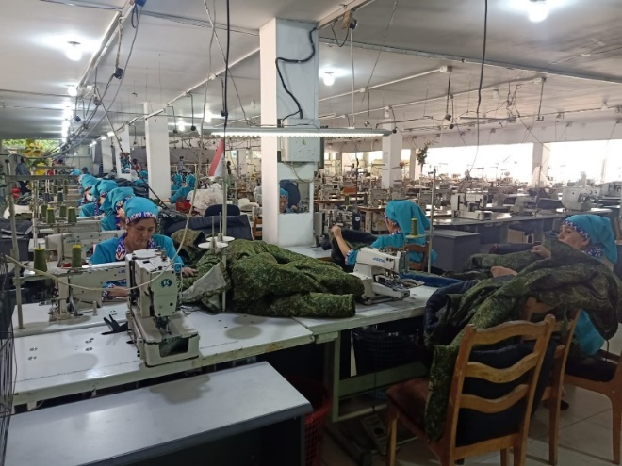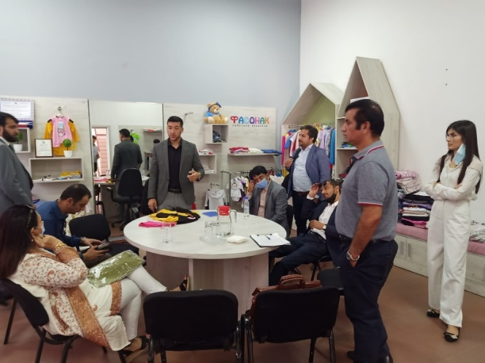

Meeting with the Tajikistan’s Ministry of Industries
- Selected delegates from mining, pharmaceutical and textile sectors had meeting with Deputy Minister of Industries, Tajikistan.
- Delegates presented their concerns regarding transportation, banking channels and availability of technical work force.
- Deputy Minister assured complete collaboration and addressal of issues highlighted by Pakistani delegates.
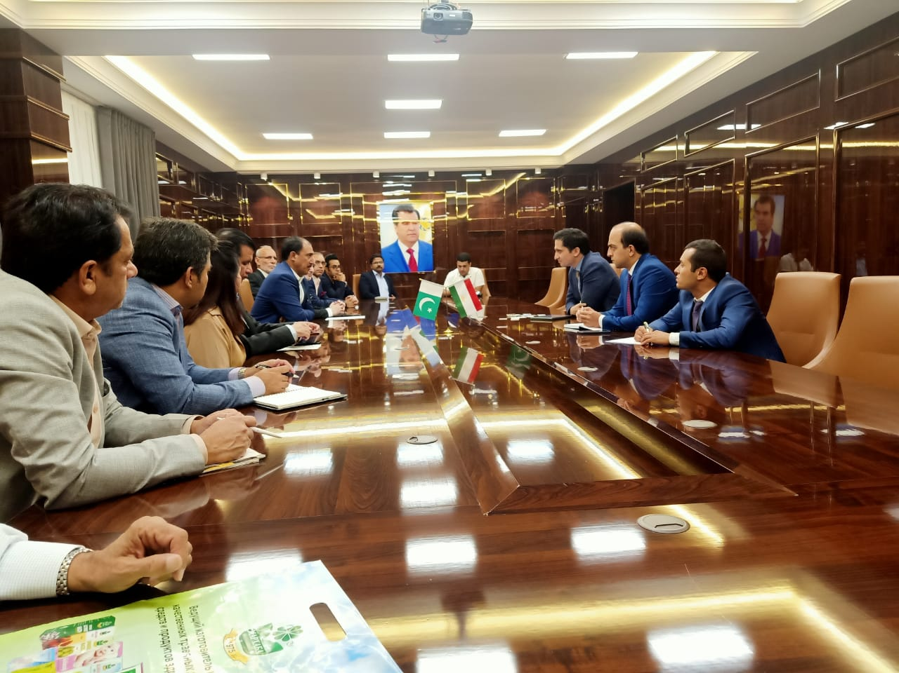

Management Teams
Two teams, TDAP Facilitation Team and TDAP B2B Team, were formed in the event led by the Director General TDAP.

TDAP Facilitation Team
This team was responsible for visa, air ticket and hotel facilitation of delegates.
TDAP Facilitation Team was comprised of following officers:
Name | Designation
Ms. Sadia Khan | Deputy Director, TDAP
Mr. Omer Hussan Bajwa | Assistant Director, TDAP (Mineral & Engineering)
Mr. Ali Raza | Assistant Director, TDAP (Textile & Leather)
Ms. Khushbakht Asif | Assistant Director, TDAP (Agro & Services)

TDAP B2B Team
B2B Secretariat was established to ensure smooth and effective facilitation and coordination of B2B meetings between the Tajikistan buyers with Pakistani delegates and with Chambers /Associations.
TDAP B2B team comprised of the following officers:
Name | Designation
Dr. Shumaila Sikandar | Deputy Director, TDAP
Mr. Omer Hussan Bajwa | Assistant Director, TDAP (Mineral & Engineering)
Mr. Ali Raza | Assistant Director, TDAP (Textile & Leather)
Ms. Khushbakht Asif | Assistant Director, TDAP (Agro & Services)

Product officers coordinated with the businessmen of Pakistan and Tajikistan buyers for successful interactions on 16th September, 2021 and subsequently follow up meetings and visits/ MoUs on 15th and 17th September, 2021.
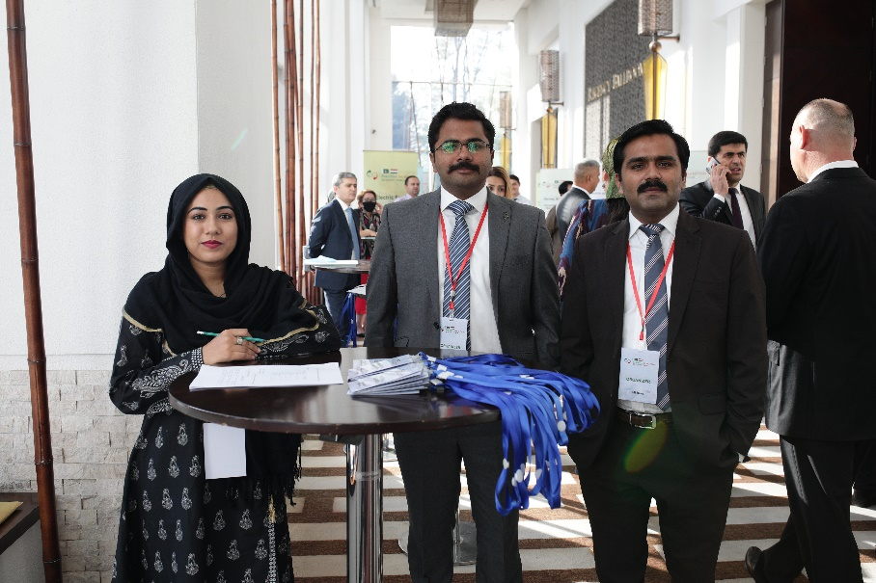

Transportation Team

Mr. Rashid Imtiaz, Trade and Investment Officer, Tajikistan was managing Transport. Coasters and buses were hired to pick delegates from airport to hotel and hotel to Conference area (Hayatt Regency). Pakistani delegates staying at two hotels (Atlas Hotel, Serena Hotel) were facilitated by Transportation Team on Event Days for pick & drop and also to airport for departure from Dushanbe.

Suggestions by delegations and Learnings / Recommendation

Suggestions by Delegations

- Establishment of Formal Banking channels between the two countries to streamline monetary transactions.
- Initiation of direct cargo flights from Pakistan to Dushanbe to reduce transportation cost.
- Logistics arrangement under TIR convention between two countries to facilitate movement of goods and reduce transportation cost.

Learning / Recommendations

- B2B Matchmaking Sessions and Business Forum may not coincide with other major events in the Host Country, such as SCO Summit in Dushanbe in the current visit.
- Allocation of separate halls for B2B sessions and Business Forum.
- Separate Q&A Session for Host country and Pakistani Delegates
- Well defined SOP’s for Q & A session in order to avoid any untoward situations.
- Inclusion of all sectors in allied activities (Visits, meetings, etc.)

Conclusion

Pakistan-Tajikistan Business forum is one of the many steps taken so far towards regional integration and paving way for Pakistan to enter Central Asian and East European markets. It has proved to be fruitful in terms of market study for new destinations, exploring potential for the Pakistani products in Tajik market, and enhancing economic relations with a brotherly nation. Owing to well-coordinated team efforts and proactive management strategies, conclusion of more than 25 MoUs and contracts on the first visit of the delegates is a healthy sign for building of economic ties between the two nations. Great potential has been witnessed in pharmaceutical, logistics, food, textile and mining sector. Tajikistan is a small market in terms of demand and consumption patterns. Its total population is smaller than the population of major cities of Pakistan. Tapping a smaller market may not enhance Pakistan’s exports to a great level, however, it can offer opportunity for market diversification and an entrance point to other Central Asian Republics and East Europe. Trade environment, such as visa facilitation, establishment of banking channels, conclusion of transit trade agreement, etc. between the two countries should be improved on priority basis.

Follow-up

Following activities are suggested to be carried out as a follow-up of the event.

- Product Specific Webinars/ B2Bs may be organized. In these webinars, respective Product officer to not only invite companies that participated in the event from Pakistani side but also leading companies of the sector who could not join the delegation and potential companies from Tajik side.
- Product specific Tajik Delegation may be invited to Visit Pakistan as a follow up to the Webinar and Virtual B2B meetings
- Single Country Exhibition to be be organized in the 1st week of March. It will be designed as B2C Component.

Annexures

List of Pakistani Delegates
Sr. NO. | Name of Company | Name of Delegate | Contact
1 | M/S National Logistic Cell | Usman Mansoor Director | 0301-8285467, 051-9052240
2 | MM Ellahi Traders | Manzoor Ellahi (Sarhad CCI) | 0300-8591066
3 | M/s Haji Fateh Khan Enterprises Pvt Ltd | Haji Fateh Khan | 081-2832885 , 03458318866
4 | M/s Yaseen Transport Co. (Pvt) Ltd | Mr. Fojan | 0332-3419607, 081-2820672
5 | Pyramid Logistics Pvt. Ltd. | Muhammad Yaqoob Shaikh, CEO | 0922135823631  yaqoob@pyramidlog.com
6 | Best Transport Pvt Ltd | Ramiz Rabbani, Director | 0313-5376712
7 | TPL Logistics | Salman Alllana | 0300-2025968  Salman.allana@tpllogistics.com
8 | Jalat Khan & Co. Pvt Ltd | Haji Nadir Khan (Chaman CCI) | 0333-7777971
9 | M/s. Qadri Transport Company | Haji Abdullah Achakzai (Quetta CCI) | 0300-8381257
10 | Faisal Movers | Ahmed Shahzad | 0321-2033666
11 | Banigala Traders pvt ltd | Hina Rafique | 0301-0110999
12 | Zafa Pharmaceuticals Laboratories Pvt Ltd | Dr. Syed Qamar Ali  Director | 03000188818  director_imbd@zafa.com.pk  alilive4others@gmail.com
13 | Sante Pvt Ltd  . | Tauqeer Ul Haq  (Managing Director) | 03000880118  thaq@sante.com.pk
14 | CCL Life Sciences | Syed Umair Maroof, Head of International Markets (CARs) | 0321-4432511  umair.maroof@cclpharma.net
15 | Friends Pharmaceuticals | Muhammad Talal Saleem, Head of Global Business, | 0321-2117559  export@friendspharma.com
16 | Davis Pharmaceuticals | Amanullah Shaikh, CEO | 051-4491851  export@davispharma.com
17 | Pacific Pharmaceuticals | Ramish Omer, CEO | 0300-8464506  Omer.ramish@pacificpharmaceuticals.com
19 | Focus & rulz Pharma | Fazli Hanan  CEO | 0344-5006363  hanan@focusandrulz.com
20 | Bio Labs Pharma | Usman Shaukat  CEO | 0300-8505129  Usman.shaukat@bio-labs.net
21 | Fedro Pharmaceuticals Lab Pvt Ltd | Junaid Altaf (SARHAD CCI) | 0300-8585188
22 | M/s. Syntex pharmaceuticals | Mirza Abdul Rehman (FPCCI) | 0300-8522322
23 | Maxitech PVT Ltd | Nadir Hasan Khan  CEO | 0314-2371133  nadir.h.khan@live.com
24 | Marhaba Laborteries | Muhammad Usman Sheikh | 0333-4237370
25 | Taqwa Pharmaceutical and Surgical | Naveed Qadir
26 | M/s Fruiti Fresh Pvt. Ltd. | Saqib Rauf | 0333-5479168
27 | Roshan Traders (Kinnow) | Khalid Ijaz | 0300-8251062  roshan@cyber.net.pk  quasimijaz@yahoo.com
28 | Al-Rafique Enterprises (Kinnow) | Muhammad Riaz | 0321-7778177  info@alrafique.com
29 | Fresh Fru | Muhammad Shahzad Sheikh | 03343102135  freshfrupakistan@gmail.com
30 | Fahad Traders | Fahad Iqbal | 03452206261  fahadhaji@hotmail.com
31 | Iftekhar & Co (IAC) | Waheed Ahmed | 03218272772  waheed@iac-fruit.com
32 | Mian Travel & Trade (Pvt.) Ltd. | Saqlain Amir Khan | 03234407224  saqlain@miansgroup.com
33 | Falcon Associates (Pvt) Ltd. | Qurban Ali (FPCCI) | 0345-8542210
34 | Gadoon Textiles | Muhammad Sohail Tabba | 0300-8297888  bilal.ayaz@gadoontextile.com
35 | Gohar Textiles Ltd. | Gauhar Mustafa, Director | 0300-8669795  gauhar@gohartextile.com
36 | Tanias Collection | Talat Hafeez Khan | 0300 8404355  t_hafeez@hotmail.com
37 | Sapphire Finishing Mills Limited | Muhammed Tahir Mehmood Khan | 0301 8404308  tahir.khan@sapphiremills.com
38 | Afroze Textile industries (Pvt.) Ltd. | Bilal Alam Lari, Director | 03213410001  bilal@afroze.com
39 | ZIS Textile, Faisalabad | Zafar Iqbal Sarwar | 0300-8665870
40 | Royal Textile Mills Limited | Muhammad Zahid Shah(FPCCI) | 0333-8598484
41 | Atom Seed Corporation | Muhammad Saleem (FPCCI) | 0300-8672003
42 | Askari Shoes Pakistan | Muhammad Kamran Aslam | 0300-7789696, Ceo.asp@awt.com.pk
43 | Kumail Gloves Industries | Qamar Munir | 030- 8714969, info@kumailent.com
44 | Wah Nobel Group of Companies | Brigadier Shiraz Ullah Choudhry, Chief Executive / Director | 0321 5333299
45 | Al Rehman Coal Company | Mir Bahrose Hussain Reki | 0300-3860399
46 | Coal & Minerals | Sardar Yahya Khan Nasir | 0300-8389644
47 | Abdul Sattar Nasar & Sons | Abdul Aziz Nasar | 0300-8388181
48 | PEL | Muhamamd Saleem | 0302-8225720

Other Delegates
49 | M/s. Farooq Group of Companies | Ghulam Farooq, (QCCI) | Edible Oil, Ghee, Flour,  PVC Pipes | 0300-8380235
50 | M/s Al-Riaz Agencies (Pvt.) Ltd. | Mian Nasser Hyatt Maggo (FPCCI) | Petrochemicals/Chemicals | 0321-8223232
51 | FPCCI | Dr. Khalid Amin Sheikh (FPCCI) | Educationist | 0300-8258005
52 | Honorary Counsel General Tajikistan in KP | Mr. Said Mahmood | Cement ,Sugar ,Cotton, Coal | 0333-9000487
53 | Quetta CCI | Muhammad Akhtar Kakar | Agriculture products, Electronics (Cell Phones) | 0323-3808888
54 | M/S. Aryana Company Limited | Abdul Rahim (FPCCI) | Handicrafts | 0300-3826500  Qcci920@gmail.com
55 |  | Dr. Abdul Wajid | Educationist | 0336-9999787
56 |  | Ghulam Hussain Shahid | Housing Sector | 0322-4295555
57 |  | Maj. Abdul Shakoor | Construction | 0303-0909090
58 |  | Nazir Chohan | Real Estate

List of Tajikistan Delegates

Sr. No. | Name of Company | Name of Person | Address | Tel | Specialty
1 | Umed Trans Logistics |  | Republic of Tajikistan, Sughd region, B. Gafurov district., J. D.Kholmatov, st. Vahdat 15 .; | 00 992 928898866 00 992 929482727 | Transport and Logistics
2 | Dunyo Advanced Logistics |  | Republic of Tajikistan, 734024, Dushanbe, st. Drujba Narodov 62 | 00 992 446107070 | Transport and Logistics
3 | CUBE |  | Tajikistan Dushanbe Bagautdinova 13/5 | 00 992 918353525 00 992 987600506 | Transport and Logistics
4 | Avas Logistics |  | Dushanbe, st. Rakhmona Nabieva 119A | 00 992 933000063 00 992 446257727 | Transport and Logistics
5 | Ikdom LLC |  | Dushanbe, Rudaki Avenue 127 | 00 992 487017575 | Transport and Logistics
6 | CargoLine LLC |  | Dushanbe, Rudaki avenue 127, 9th floor | 00 992 446250013 | Transport and Logistics
7 | ABM Trans Service |  | Dushanbe, Mirzo Tursunzade Street 38/1, apt. 9 | 00 992 372270046 | Transport and Logistics
8 | Mavsim and Ko |  | Dushanbe, st. Bokhtar 37/1 | 00 992 555551701 | Transport and Logistics
9 | Dali Logistic Company |  | Dushanbe st. Foteh Niyozi | 00 992 779996002 00 992 930990000 | Transport and Logistics
10 | M&M Militzer & Münch Tajikistan LLC |  | Rudaki Avenue, 127, Business Center “Rudaki Plaza”, 722 | 00 992 933310882 00 992 487015331 | Transport and Logistics
11 | Tajikvneshtrans CSJC |  | Dushanbe, 734061, st. Yujnaya obkhodnaya, 3 | 00 992 361300044 00 992 361300045 00 992 987340909 | Transport and Logistics
12 | Varzob Trans |  | Dushanbe 33rd microdistrict south of the building of the Republican traffic police along Jabbor Rasulov street. | 00 992 2381919 00 992 985053015 00 992 935142274 | Transport and Logistics
13 | State Unitary Enterprise "Automobile Transport and Logistics Services" of the Ministry of Transport of the Republic of Tajikistan |  | Dushanbe, st. Aini-14 a, | 00 992 372216720 00 992 372216724 00 992 372278942 | Transport and Logistics
14 | East |  | Dushanbe, st. Karamova 4, Business Center Orio. Near the Agrarian University. | 00 992 37243539 00 992 2243540 00 992 919504304 00 992 918401005 | Transport and Logistics
15 | Move One |  | Dushanbe, Poitakht Business Centre  4th Floor, Office #409 | 00 992 486403131 | Transport and Logistics
16 | Association of International Road Carriers of Republic of Tajikistan "ABBAT" |  | Dushanbe, st Kahhorov 592 | 00 992 446000540 | Transport and Logistics
17 | Enex-Logistics Co., LTD |  | Dushanbe, st Abdullobekova 6 | 00 992 378853536 | Transport and Logistics
18 | Favran Logistics |  | Dushanbe, st N. Muhammad 5/5 | 00 992 919161803 | Transport and Logistics
19 | Bek Express |  | Dushanbe | 00 992 937359999 | Transport and Logistics
20 | Mada trans |  | Dushanbe/ F Niyozi 54 | 00 992 933000063 | Transport and Logistics
21 | LLC Siyovush |  | Dushanbe | 00 992 920202020 | Transport and Logistics
22 | Rohi Somon LLC |  | Khujand city, street K. Khujandi 43/18 | 00 992 927770461 00 992 342240720 | Transport and Logistics
23 | Ministry of Transport |  | Dushanbe, str Ayni 14 | 00 992 372211713 | Transport and Logistics
24 | Sifat Pharma |  | info@sifatpharma.tj | 00 992 446010307 | Pharmaceutical
25 | Dar-Dar |  | dar-dar@list.ru | 00 992 446000285 00 992 446000288 | Pharmaceutical
26 | Rakhmat-2004 |  | rahmatullo@inbox.ru | 00 992 907744892 00 992 905004831 | Pharmaceutical
27 | Shahrior-2000 |  | Kafolat2000@gmail.com | 00 992 985037779 | Pharmaceutical
28 | Unopharm |  | info@unopharm.tj | 00 992 556008008 | Pharmaceutical
29 | Tib Baroi Shumo |  | tbsh@inbox.ru | 00 992 372608064 | Pharmaceutical
30 | Lavozimoti Tibbi |  | Ltibbi-2003@mail.ru | 00 992 372608067 | Pharmaceutical
31 | Farmico |  | info@pharmiko.tj | 00 992 918475288 00 992 918908326 | Pharmaceutical
32 | Gulmuhammad |  | gulmuhammad@mail.ru | 00 992 487016430 | Pharmaceutical
33 | Ibni Sino |  | ibnisino@mail.ru ; info@ibnisino.tj | 00 992 446400102 | Pharmaceutical
34 | Apteka-24 |  | info@apteka24.tj | 00 992 987242043 00 992 938185752 | Pharmaceutical
35 | Al-Baraka LLC |  | office@albaraka.rocks | 00 992 988620031 | Pharmaceutical
36 | Khushbahtion |  | khushbakhti@yahoo.com | 00 992 372312611 00 992 918100014 | Pharmaceutical
37 | Tibtajhizot |  | Ttt.tj@yandex.ru | 00 992 934145070 | Pharmaceutical
38 | Emiti LLC |  | emity-tj@mail.ru | 00 992 927079995 | Pharmaceutical
39 | Dusti LLC |  | info@dusti.tj | 00 992 372368966 | Pharmaceutical
40 | Muhammad A LLC |  | vokhidovr@hotmail.com | 00 992 378832276 | Pharmaceutical
41 | Express-Pharm LLC |  | info@expresspharm.tj |  | Pharmaceutical
42 | Garant Wholesale Pharmacy |  |  | 00 992 918272098 | Pharmaceutical
43 | Shahdi LLC |  |  | 00 992 918882222 | Pharmaceutical
44 | Ekonom LLC |  |  | 00 992 987681111 | Pharmaceutical
45 | Darmon LLC |  |  | 00 992 933108888 | Pharmaceutical
46 | Abubakri Karim LLC |  |  | 00 992 918366000 | Pharmaceutical
47 | Mijgona LLC |  |  | 00 992 985105505 | Pharmaceutical
48 | Afzal LLC |  |  | 00 992 501001320 | Pharmaceutical
49 | Nuri Tib LLC |  |  | 00 992 889900202 | Pharmaceutical
50 | Khushbahtion LLC |  | khushbakhti@yahoo.com | 00 992 372312611 00 992 918100014 | Pharmaceutical
51 | Hayom LLC |  |  | 00 992 918682571 | Pharmaceutical
52 | Itminon LLC |  |  | 00 992 985037779 | Pharmaceutical
53 | Vita LLC |  |  | 00 992 985186644 | Pharmaceutical
54 | Ministry of Health and Social Protection of the Population of the Republic of Tajikistan |  | info@moh.tj http://moh.tj/ | 00+B5:D43 992 372211248 00 992 446006002 | Pharmaceutical
55 | Pharmaceutical association of Republic of Tajikistan | Sayfullozoda Fayziddin |  |  | Pharmaceutical
56 | LLC “Tibbi Tojik” | Hamidov Jamshed |  |  | Pharmaceutical
57 | Union of Pharmacist of Tajikitan | Mingboev Latif |  |  | Pharmaceutical
58 | LLC Sino-2013 | Sharipov Bahodur |  |  | Pharmaceutical
59 | LLC “Sifat farma” | Kholov Sherali |  |  | Pharmaceutical
60 | LLC “Farmiko” | Imomiyon Ravshan |  |  | Pharmaceutical
61 | LLC Fardsughd | Kholov Dilovar |  |  | Pharmaceutical
62 | LLC «Nek-Farm» | Athamov Zayniddin |  |  | Pharmaceutical
63 | LLC «Farm Somoni» | Rahmatov Ismoil |  |  | Pharmaceutical
64 | LLC «Khatlon Pharmatisya» | Murodov Ilohiddin |  |  | Pharmaceutical
65 | LLC «Hazorispand» | Olimov Taghoimurod |  |  | Pharmaceutical
66 | LLC “Shohyor” | Shohev Bakhtiyor |  |  | Pharmaceutical
67 | LLC “Kanzi shifo” | Boboev Jangikhon |  |  | Pharmaceutical
68 | Schiever Tajikistan |  | akarimova@schiever.tj contact@schiever.tj | 00 992 488884005 | Food Sector
69 | Tajero LLC |  | info@tajero.tj | 00 992 446011122 | Food Sector
70 | Real Traiding LLC |  | info@paykar.tj boltaev.i@paykar.tj | 00 992 446302020 | Food Sector
71 | Evar |  | info@evar.tj | 00 992 985556060 | Food Sector
72 | Amid Group LLC |  | amidgroup.tj@gmail.com | 00 992 927736771, 00 992 927737111 | Food Sector
73 | Rushon Distribution Inc |  | office.rushon@rosellagroup.com | 00 992 372360605 | Food Sector
74 | Mr. Zubaidullo |  |  | 00 992 886880887 | Food Sector
75 | LLC “Leader” |  | info@leader-ltd.tj import@leader-ltd.tj | 00 992 446305005 00 992 927737111 | Food Sector
76 | Huseynzoda 55 LLC |  | huseinzoda-55@mail.ru | 00 992 918612147 00 992 935112255 | Food Sector
77 | Rohi Somon LLC |  | info@rohisomon.com | 00 992 927770461 00 992 342240720 | Food Sector
78 | Farovon-1 LLC |  | info@farovon.tj | 00 992 777173131 | Food Sector
79 | Mr. Boboyev Yusufjon |  | weigaogroup@mail.ru | 00 992 907971897 | Food Sector
80 | OJSC Urunhojaev |  | godiro_1989@mail.ru | 00 992 927705611 | Food Sector
81 | Nargis-2016 |  | osim_gaforov@mail.ru | 00 992 927743888 | Food Sector
82 | JSC Abrikos and Company |  | rasulov07@mail.ru | 00 992 927126100 | Food Sector
83 | LLC Qosimjon |  | qurbonzoda@icloud.com | 00 992 985557273 | Food Sector
84 | Mr. Parvizi Jamshed |  | hamadoni-27@mail.ru | 00 992 904013300 | Food Sector
85 | Dusti-2 LLC (Mr. Bahrovar) |  | abdulloev.dusti@gmail.com | 00 992 888800888 | Food Sector
86 | Siyoma |  | info@siyoma.tj | 00 992 909009900 | Food Sector
87 | Obi Zulol |  | info@obizulol.tj | 00 992 446306324 | Food Sector
88 | Muhammad Orifov |  |  | 00 992 907990606 | Food Sector
89 | Alika LLC |  | info@alika.tj | 00 992 446404747 00 992 915030423 | Food Sector
90 | Mr. Mokim Zokirov |  |  | 00 992 985163910 00 992 935993910 | Food Sector
91 | State unitary enterprise - Food in Sughd region | Abdulnazarov Firuz |  |  | Production of alcoholic product
92 | LLC “Fabrikai shiri saodat” | Komilov Ilhom |  |  | Food production
93 | LLC Shirin | Yoldoshev Siyovush |  |  | Food production
94 | Service center «Shomi Jomi» | Ibragimova Mahramoy |  |  | Food production
95 | LLC «Grin-Gold» | Abdulov Khudoidod |  |  | Processing and packagind of pistachios
96 | LLC “Nonpazi Hisor” | Qalandarov Alisher |  |  | Production of flour
97 | JSCC «Avvalin» | Hamroev Najib |  |  | Dried fruit
98 | CE «Imomi Azam» | Azimov Azim |  |  | Dried fruit
99 | JSOC “Fabrikai shirin” | Davlatov Qobiljon |  |  | Production of confectionery
100 | LLC “555 МПК” | Rahimov Zikriddin |  |  | Production of confectionery and dairy
101 | LLC “Alibobo & 40К” | Nabizoda Farhod |  |  | Food production
102 | LLC “Noni Konibodom” | Abdulojonov Farhod |  |  | Food production
103 | LLC “Zarafshoni Sino” | Burieva Mehrikhon |  |  | Production of fruit juices
104 | LLC “Tajam” | Alimadov Umar |  |  | Manufacture of beverage products
105 | LLC “Zarafshoni Sino” | Burieva Mehrikhon |  |  | Production of fruit juices
106 | LLC Noni Konibodom | Abdulojonov Farhod |  |  | Food production
107 | LLC “Anas-AO” | Khoshakova Shulamo |  |  | Production of confectionery and fruit juices
108 | LLC “Yovar” | Rahmonov Asadullo |  |  | Production of sausages and logistic products
109 | LLC “Nerui Oftob” | Sharipov Abdulqosim |  |  | Production of confectionery
110 | LLC “Alibobo & 40к” | Umarov Igor |  |  | Food production
111 | ҶСК “Ravghani Tojik” | Saidov Abdusaid |  |  | Oil production
112 | GoTravel Tajikistan | Farrukh Hojatov | Dushanbe, st Tehron 21 | 00 992 989125555 | Tourism
113 | LLC "Zigana Tour" | Rakhimov Mekhroch | Dushanbe st. M. Tursunzoda building 9 | 00 992 372276058 00 992 918468580, 00 992 918640618, 00 992 935999969, | Tourism
114 | Sky Tour LLC | Ajidzhemil Manzura | Dushanbe b. I. Somoni st. M. Tursunzoda 45 | 00 992 372240005, 00 992 372215050 00 992 446202040, 00 992 908688090, 00 992 918485597 | Tourism
115 | LLC "AAA-Tour" | Rakhmatulloev Rustambek | Dushanbe b. Shokhmansur, st. A. Donish 19 | 00 992 905003773, 00 992 935657417, 00 992 446402777 | Tourism
116 | Voyage Tour LLC | Atachonov Azamat | Dushanbe, b. Sino, street Mayakovsky 29/3 room 13 | 00 992 446259361 00 992 918551166, 00 992 918991771 | Tourism
117 | LLC "Rasulsohtmon" Director | Kurbonov Saddullo | Dushanbe city Shokhmansur st. Valamatzoda 8 | 00 992 372387584, 00 993722274466, 00 992 934446656, 00 992919626200 | Tourism
118 | Pamir Mountain Travel LLC Director | Hasanov Sadullo, | Penjikent, town B. Kholmurodov, st. "Central-1" | 00 992 347555088, 00 992 372240213, 00 992 927718646, 00 992 935993737 | Tourism
119 | LLC "Sugdiyon - Pomir Tour" | Rustamov Mirzorustam | Sughd region, R. B. Gafurov,Goziyon village, st. Chorsu 38 | 00 992 927774469, 00 992 927051728 00 992 927070175 | Tourism
120 | LLC M. Tour | Khasanova Musharaf | Dushanbe Rudaki avenue 20 | 00 992 372277025, 00 992 372210500 00 992 907719343, 00 992 935821849 | Tourism
121 | CJSC "Council for Tourism and Excursions" | Sobirov Majid | Dushanbe Rudaki avenue 20 | 00 992 372277051, 00 992 372277043, 00 992 907700400, 00 992 935999115, 00 992 935821849 | Tourism
122 | LLC "Gandzhina" | Amirov Saydali | Dushanbe st. N.Karabaev 100 | 00 992 372342362 00 992 935003222, 00 992 918772993 | Tourism
123 | LLC "Saodat Sayr" | Rhizosoda Saodachi Holik | Dushanbe n. Firdavsi, st. N. Karaboev 118 | 00 992 372216031, 00 992 372232392 00 992 90 7725949, 00 992 918655800 | Tourism
124 | Javokhir LLC | Kholov Tojiddin | Dushanbe st. Bokhtar 21 a | 00 992 372215911, 00 992 93 5147560, 00 992 98647560 | Tourism
125 | LLC "Kafolat" | Saymutdinov Muzaffar | Dushanbe st. Pushkin 85 | 00 992 372213547, 00 992 918 803055, 00 992 90 7558888, 00 992 91 9000909 | Tourism
126 | LLC "Sayokhati Rohi Abreshim" | Azizov Anvar | Dushanbe Shokhmansur st. Pushkin 85 | 00 992 918 740757 | Tourism
127 | AKF | Faizulloev Akhmadchon | Dushanbe r. Shokhmansur st. F. Attor | 00 992 918 656564, 00 992 918614553 00 992 935001441 | Tourism
128 | LLC El-Tour | Shahidi Faridun | Dushanbe r. Shokhmansur st. Aini 46 | 00 992 918 751272, 00 992 918749866 00 992 918615145 | Tourism
129 | LLC "Guides of the Pamir" | Goybuldaev Saitaaly | GBAO, r. Murgob st. O. Ismonova 51 | 00 992 93 5382545, 00 992 935272629 00 992 935329587 | Tourism
130 | PA "Palmira International Group" | Rashidova Kamila | Dushanbe city, Shokhmansur st. Aini 46 | 00 992 372276672, 00 992 935059404 | Tourism
131 | LLC "Tadjinturservice" | Kobilov Zafar | Dushanbe st. Pushkin 22 | 00 992 372278204, 00 992 93 5050855 | Tourism
132 | LLC "Orient Adventure" | Khamrokulov Khudoikul | Dushanbe st. Huseynzoda 34 | 00 992 372270627, 00 992 95 1552296, 00 992 935266903, 00 992 90 7845503 | Tourism
133 | LLC "Alfa-Tour" | Sharofiddinov Akmalkhon | Dushanbe, Rudaki avenue 58 | 00 992 372215028, 00 992 918628572 | Tourism
134 | LLC "Association Tourism Development Zerafshan" | Kayumov Jamshed | Panjakent city st. X Sherozy 47 R. Aini, st. Aini 1 | 00 992 347556339 00 992 92 7746202, 00 992 927175559 | Tourism
135 | LLC "Nasim 91" | Saidov Ibrokhim | Dushanbe st. Aini 42-5 | 00 992 372217329, 00 992 918189392, 00 992 935014242, 00 992 935011111 | Tourism
136 | LLC Didori Shark | Mirzoev Mirzonazar Zokhirovich | Dushanbe R. I.Somoni st. Bokhtar 2 | 00 992 372212324 00 992 93 858555, 00 992 904367777 | Tourism
137 | LLC Bipar | Ayubov Isfandiyor |  | 00 992 919890808, 00 992 985455511, 00 992 985086699 | Tourism
138 | LLC "Vostok Trading Tour" | Miraliev Aziz | Dushanbe, st. Pushkin 14 | 00 992 372270112, 00 992 372270113, 00 992 93 5010000 | Tourism
139 | LLC Central Asian Tourism | Nazirov Kamshed | Dushanbe city I. Somoni st. I.Somoni 14 | 00 992 372245630, 00 992 918 661155, 00 992 90 7511150, 00 992 918 684616 | Tourism
140 | LLC "Rohat Tour" | Abdurakhimov Umedchon | Dushanbe b. Shokhmansur st. Aini 32 | 00 992 372231122, 00 992 904602211, 00 992 918616125, 00 992 918316463 | Tourism
141 | Pamir Silk Travel LLC | Davlatov Ozodabegim | GBAO, Khorog, st. Azizbekov 1 | 00 992 352222299, 00 992 935718090, 00 992 935052361 | Tourism
142 | LLC "Zurmich" | Nizomov Nasriddin | Sughd region, Panjakent city, Bakoli street 24 | 00 992 347554543, 00 992 927599123, 00 992 927621636 | Tourism
143 | Pamir Peaks LLC | Erov Dodhudo | Dushanbe, b. Firdavsi st. Firdavsi 66/7 | 00 992 935001111, 00 992 447013333 | Tourism
144 | Intourist-Tojikiston CJSC | Abdullaeva Zarina | Dushanbe b. I. Somoni, st. Shotemur 22 | 00 992 985614771, 00 992 918895922, 00 992 918622171 | Tourism
145 | LLC "Tajikaviatur" | Fayzulloev Fattoh | Dushanbe st. Bukhoro 32 | 00 992 372211800, 00 992 372211934 | Tourism
146 | LLC "Diana va T" | Niyozmadova Gulru | Dushanbe r. Sino, st. Mukhammadiev 11/6 | 00 992 372375924 00 992 907746413, 00 992 919000899 | Tourism
147 | LLC "Zerafshan Magic Travel | Turakulov Firdavs | Sughd region, Panjakent city, Rudaki avenue 58 | 00 992 347552155, 00 992 927300803, 00 992 927350395 | Tourism
148 | Committee for Tourism Development under the Government of the Republic of Tajikistan | Tojiddin Jurazoda | Dushanbe, Rudaki ave 40 | 00 992 372278480 | Tourism
149 | Travel company Artuch | Muhammadzoda Eraj |  |  | Travel service
150 | Travel Association of Panjakent | Norov Zafar |  |  | Travel service
151 | Council association of Zarafshon | Yusipov Jamshed |  |  | Travel service
152 | LLC «Sayri jahon» | Sharipov Saymuddin |  |  | Travel
153 | Travel agency “Ittifoqhoi Kasabai Tojikiston” | Nodiri Maruf |  |  | Travel service
154 | LLC “Kafolat” | Saymiddinov Muzafar |  |  | Travel service
155 | Yokut-2000 |  | Dushanbe, str Valamadze 52 | 00 992 2218795 | Textile
156 | JV "Giavoni" LLC |  | Tajikistan, Khudjand | 00 992 342265167 | Textile
157 | Guliston Dushanbe |  | Dushanbe, str Tehron 21 | 00 992 2275683 | Textile
158 | OJSC “Kairakkum Carpets” |  | Tajikistan, Qayroqqum city, 1, Kovrovshikov str. | 00 992 344323403 | Textile
159 | Sifat Sanoat |  | Dushanbe, str Behzod 8 | 00 992 935051987 | Textile
160 | Insoft |  | Dushanbe, str Buhoro 2 | 00 992 935558241 | Textile
161 | PO Nasochii Tojik |  | Dushanbe, str Shadii Sherozi 6 | 00 992 919392255 | Textile
162 | SP VT Rohi Abreshim |  | Dushanbe, str Ahmadi Donish 5/2 |  | Textile
163 | Nohid LLC |  |  | (+992 3454) 2 7620 | Textile
164 | Ortex LLC |  |  | (+992 92) 999 92 46, (+992918) 43-63-90 | Textile
165 | AO Nafisa |  | Tajikistan, Dushanbe, str Asad Ahmadov 11 | 00 992 372277163 | Textile
166 | CJSC Olim-Textile |  | Tajikistan, Dushanbe | 00 992 372234242 | Textile
167 | OJSC "Kairakum Carpets" |  | Tajikistan, Kairakum, str Kovrovshikov 1 | 00 992 344323403 | Textile
168 | Spitamen Textile LLC |  | Tajikistan, Spitamen, str Saidova 45 | 00 992 344122200 | Textile
169 | Nekoo Khujand LLC |  | Tajikistan, Khudjand, North-Eastern Industrial Zone | 00 992 342251684 | Textile
170 | Textile-City LLC |  | Tajikistan, Khujand, str. Lenin 238 | 00 992 342263420 | Textile
171 | CJSC “SATN” |  | Tajikistan, Khujand, str. Lenin 238 | 00 992 342266302 | Textile
172 | “Leader” LLC |  | Tajikistan, Khujand 2 a, Baraka Babaev str | 00 992 342261684 | Textile
173 | OJSC “Kulob Textile” |  | Tajikistan, Kulob city, Shohtemur vilage | 00 992 338726037 | Textile
174 | CJSC “Zinat” |  | Tajikistan, Khujand 2 a, Baraka Babaev str | 00 992 927710577 | Textile
175 | “Hima Textile” LLC |  | Tajikistan City Dushanbe 21, Pavlova str. | 00 992 372248136 | Textile
176 | OJSC "Resanda" of Kurgan-Tyube |  | Tajikistan Kurgan-Tyube 2 a, Ayni str. | 00 992 322227364 | Textile
177 | “Farres” LLC |  | Tajikistan Farkhor Jamoat Gulshan | 00 992 372311977 | Textile
178 | De-Facto Tajikistan |  | Dushanbe Rudaki ave | 00 992 920202020 | Textile
179 | Milanomode |  | Dushanbe | 00 992 446254242 | Textile
180 | Ms. Nafisa Imranov |  |  |  | Fashion Designer
181 | Ms. Nisso Kayumova |  |  |  | Fashion Designer
182 | Ms. Mavlyuda Khamraeva |  |  |  | Fashion Designer
183 | Mr. Umed Kuchkaliev |  |  |  | Fashion Designer
184 | Mr. Khursheed Sattarov |  |  |  | Fashion Designer
185 | Private Sector Development of Tajikistan | Rajabov Fayzali |  |  | Textile
186 | Private Sector Development of Tajikistan | Normatova Naima |  |  | Textile
187 | Private Sector Development of Republic of Tajikistan | Muhammadiev Abdullo |  |  | light textile industry
188 | LLC “Kiparis-2010” | Makhanov Rustam Abdulkhatovich |  |  | Processing of cotton
189 | JSOC “Resandai Kurgonteppa” | Abdukarimov Orifjon |  |  | Spinning, weaving, seving
190 | LLC “Sugd Textile” | Oripov Ilhomjon |  |  | Spinning
191 | LLC “Neku Khujand” | Karimov Zokirov |  |  | Spinning
192 | LLC “Hima textile” | Kulov Khayom Sharifovich |  |  | Spinning
193 | LLC “Kosibon” | Mahmudov Ghaibullo |  |  | weaving
194 | LLC “Vahdat Textile” | Mirzoev Ilhom |  |  | Knitting
195 | LLC “Lider” | Islomiddinov Sayidamon |  |  | seving
196 | LLC “TojTex” | Abduhamidov Abdurashid |  |  | seving
197 | Joint venture - Javoni | Pulotov Akramjon |  |  | Textile
198 | LLC «Zebo» -75 | Burhonova Shahlo |  |  | Sewing
199 | LLC «Mavluda» | Safarova Mavluda |  |  | Sewing Chakan
200 | LLC “Yoqut-2000” | Qodirzoda Abduhalim |  |  | Sewing
201 | LLC “Итиҳодияи истеҳсолии насоҷии тоҷик” | Qurbonov Anvar |  |  | Textile
202 | LLC "Leather Khujand" |  | Guliston city | 00 992 927577555 00 992 929233000 | Wet-blue
203 | LLC "Tajik transfer" |  | Dushanbe city | 00992 915051688 00 992 904462446 | Wet-blue
204 | LLC "Matin Leather" |  | Dushanbe city | 00 992 937062525 | Wet-blue
205 | LLC "Leather" |  | Dushanbe city, str Kakhhorov 12 a | 00 992 372606060 00 992 935272727 | Leather footwear
206 | Azam LLC |  | Dushanbe str Ayni 14/2 | 00 992 929951010 | Leather footwear
207 | LLC Poyafzolduzi Khujand |  | Khujand  K. Khujandi St. 6 | 00 992 927592070 00 992 342242243 | Production of footwear man's, female, children's and other  products from a genuine leather
208 | LLC «poyafzoli charmi» | Abdiev Karomatullo |  |  | Shoes production
209 | “Shakhtaifon-yagnob” subsidiary company of the SUE “AngishtiTojik” |  | fon-yagnob@mail.ru | 00 992 908881111 00 992 777073010 | Coal
210 | OJSC "Angisht" |  | rajabov_8880@mail.ru | 00 992 939189000 00 992 928920800 | Coal
211 | CF KA "Ziddi" |  | kaziddi@mail.ru | 00 992 900004004 | Coal
212 | CJSC "Tajik Metallurgical Plant" |  | alisher.muminzoda@faroz.tj | 00 992 902020266 | Coal
213 | LLC "TALCO-Resource" (SUE "SHAT") |  | snodirova_95@mail.ru | 00 992 915199999 | Coal
214 | LLC "Kudrat-2010" |  | murodi89@mail.ru | 00 992 906600000 | Coal
215 | LLC "Vienna" |  |  | 00 992 909909909 | Coal
216 | LLC "Daryo-2015" |  |  | 00 992 935110700 | Coal
217 | UE "Koni angishti "Shuroobod" |  |  | 00 992 918730887 | Coal
218 | LLC JV "Zarafshon" |  | umedjonziyoev@gmail.com | 00 992 927070005 | Gold
219 | JSC "GOK Adrasmansky" |  | adrasmon@mail.ru | 00 992 344324176 | Gold
220 | LLC "Aprelevka" |  |  | 00 992 927807674 00 992 927224094 | Precious metals
221 | Talco |  | info@talco.com.tj | 00 992 474462021 00 992 313022081 | Aluminium
222 | Gayur LLC |  | info@gayur.tj info@gayur.com | 00 992 907884848 | Cement
223 | LLC MPK Zhongtsai Mohir Cement |  | dilafruzam@gmail.com | 00 992 552553000 | Cement
224 | Ministry of Industry and New Technologies of the Republic of Tajikistan |  | info@sanoat.tj | 00 992 372215259 | Mining
225 | Alif Bank |  |  |  | Fintech Company providing online platform for selling
226 | Mr Anvar |  |  |  | Importer/Distributor
227 | LLC “Noqili Talco” | Ismatzoda Mahmud |  |  | Cable products
228 | LLC “Ganj 2000” | Qodirov Daler |  |  | Production of cement and stone products
229 | LLC “Vohidiyon” | Vohidov Tojidin |  |  | Construction
230 | LLC “Markazi istehsolii nedra” | Vohidov Akram |  |  | Construction
231 | LLC “Ramzan Sokhtmon” | Fatkulloev Qadriddin |  |  | Construction
232 | LLC “Tojikmarmar” | Shahidov Saymir |  |  | Manufacture of marble products
233 | Director | Usmonova Amina |  |  | Folk cratfs
234 | LLC “Rukhom” | Muhabbatov Mufarakh |  |  | Crafts and folk crafts
235 | LLC “Asrori Sang” | Sharifi Daler |  |  | Crafts and folk crafts
236 | LLC “Sultoni Kabir” | Kabirov Sulton |  |  | Trading
237 | LLC “Partnyor” | Juraev Umedjon |  |  | Trading
238 | JSCC “Torgmash” | Kholov Fayzkhon |  |  | Manufacture of power tools
239 | LLC “Tojikcrystall” | Abdurahmonov Umedjon |  |  | Manufacture of jewerly
240 | LLC “Tojikmebel” | Mukhakov Homidjon |  |  | Production of furniture
241 | LLC “Intermebel” | Kamolov Abdurahim |  |  | Production of furniture
242 | LLC “Mavji istiqlol” | Husainov Siyovush |  |  | TV cable services
243 | Discovery, analise, Consultation | Mamadalibekov Daler |  |  | Propaganda
244 | LLC “Aqiqa” | Abdurahmonov Bahrom |  |  | Manufacture of jewerly
245 | LLC “Душанбе мол” | Kamolov Amrullo |  |  | Services
246 | LLC “Redline” | Habibov Sharaf |  |  | Services
247 | PI & BD. ш.Душанбе “ | Qodirov Mirali |  |  | Services
248 | PI & BD c. Dushanbe | Qodirova Sayora |  |  | Services

