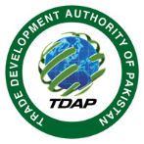
Government of Pakistan
Trade Development Authority of Pakistan
62-Garden Block, Garden Town, Lahore
Phone: 042-111-444-111 Fax:042-99230609

GOVERNMENT OF PAKISTAN

Dated: 4th February 2022
EVENT REPORT

SUBJECT: SEMINAR ON ‘MARKET INTELLIGENCE TOOLS’

Agenda: To equip women entrepreneurs and SMEs with the right set of tools, so that they may have easy access to trade-related information for export development

Date and Time: Friday, 4th February 2022 at 1100 hours
Duration: 3 hours (11:00 am – 2:00pm)
Venue: Conference Room, Trade Development Authority of Pakistan, Lahore Office
No. of participants: 60 persons (online and in-person)

Trade Development Authority of Pakistan (TDAP), in collaboration with International Trade Centre (ITC), organized a seminar on ‘Market Intelligence Tools’ on 4th February 2022 at TDAP Lahore Office for the capacity building of SMEs and women entrepreneurs in Pakistan. The purpose of the seminar was to promote SMEs and women entrepreneurship development by equipping the participants with the right set of tools and ideas to equip the participants to conduct strategic market research for export readiness and improve their product outlook. The seminar was also aligned with TDAP’s upcoming WEXNET 2022 exhibition and complimented its main theme i.e. ‘W.E Experience IT’.
This was the first in a series of planned seminars throughout Pakistan, leading to the upcoming WEXNET exhibition scheduled March 2022 at Expo Centre Lahore. The seminar was attended by 60 participants, with Ms. Farzana YakoobITC Consultant) as guest speaker.
Mr. Muhmmad Shoaib Zafar, Advisor (Trade Policy) ITC-ReMIT, spoke on the efforts of ITC in providing technical assistance to the Ministry of Commerce to increase Pakistan’s international trade competitiveness with special focus on women and SMEs. Afterwards, Ms. Farzana Yaqoob (ITC Consultant) gave a comprehensive presentation and deliberated upon on a wide array of ITC’s market analysis tools including, but not limited to, Trade Map, Investment Map, Market Access Map and Export Potential Map. The aim was to help participants gain an understanding of and access to one of the world’s largest trade database.

Questions were welcomed throughout the session to help answer participants’ queries. In the end, certificates were distributed to all the participants for their active participation.

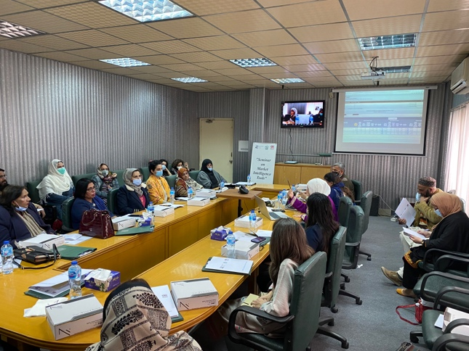
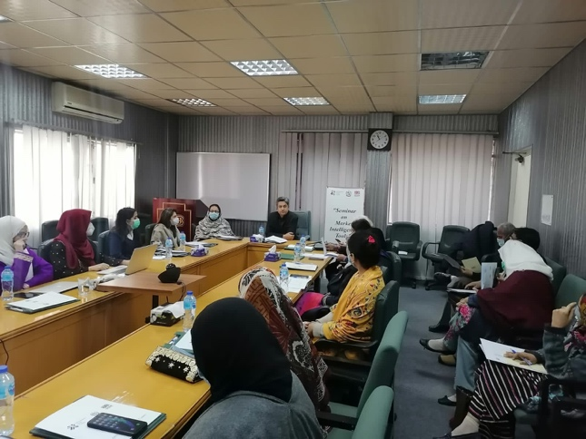
Picture Gallery:
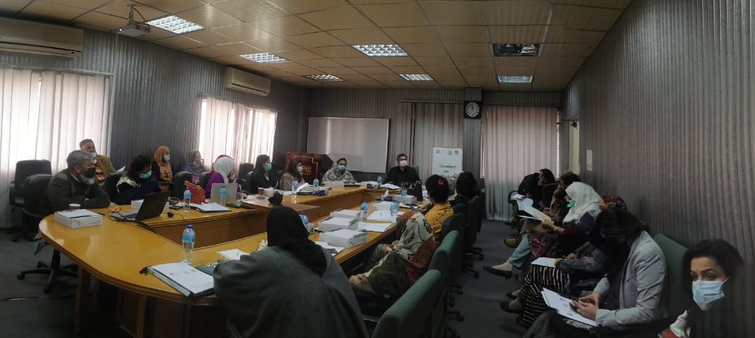
Feedback:
Feedback forms were distributed to the audience. The results of which are as follows:

Regarding the usefulness of the information provided at the session, 67% of the participants responded ‘Excellent’ and 28% responded ‘Good’. Only 5% responded ‘Neutral’.

The participants were also asked whether the session was well-organized and well-facilitated. Majority of the respondents i.e. 62% responded ‘Excellent’, 24% responded ‘Good’ and 14% responded ‘Neutral’. Overall, the participants appreciated the initiative.
Suggestions by Participants:
1) More sessions like these need to be organized
2) More trainings with focus on best export practices and products, how to search for buyers, customs and taxation.
3) There should be a session on ‘Stories Shared by Successful Women’
4) Practical activities pertaining to imports and exports
5) Applicants should be filtered out for technical trainings

