Dated: February 03, 2021

VISIT OF AMBASSADOR OF PAKISTAN TO LIBYA AT GUJRANWALA CHAMBER OF COMMERCE & INDUSTRY ON FEBRUARY 3, 2021

H.E Maj. Gen. Rtd. Rashid Javaid, Ambassador of Pakistan to Libya alongwith former Ambassador H.E Maj. Gen. Rtd Sajid Iqbal Paracha visited Gujranwala on February 3, 2021 in connection with holding a meeting at Gujranwala Chamber of Commerce & Industry (GCCI). GCCI Meeting scheduled from 1200 – 1330 hours. Mr. Umar Ashraf Umar, President GCCI warmly received the honorable Ambassador.
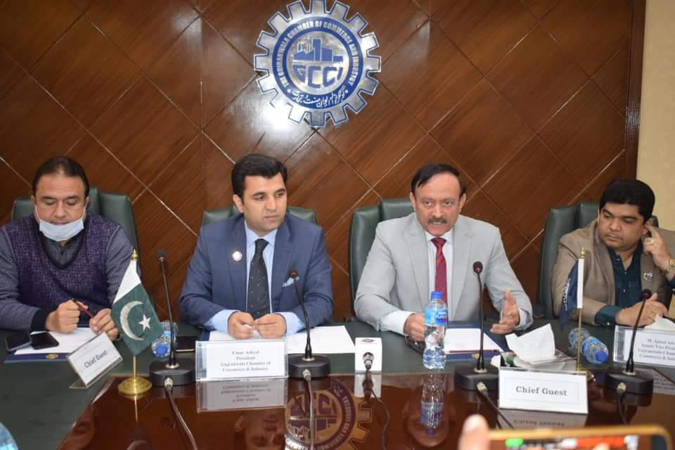
2. After a formal introduction with the President GCCI an introductory session was held with the Executive Committee Members of the GCCI. The Ambassador talked about the Libyan crises, current political situation, seize fire and economy factors. He apprised the session about the total population of Libya which was 6.4 million in 2017 with free education and compulsory literacy rate upto 86.1%. He added that way of life of Libyans are close to Pakistani culture. He reasoned, toppling of long term leader Mummar Gaddafi in 2011 led to a power vacuum and instability, which no authority in full control. He also elaborated role of Khalifa Haftar, leader of the Libyan National Army, which controls much of eastern side supported by Russia and GNA-Prime Minister Fayez Sarraj, Head of the UN – recognized government in Tripoli supported by Turkey.
3. He attracted attention of the session on the points regarding improvements political situation and peace & security. Libya’s Civil conflict reignited in April 2019 when Khalifa Hiftar LNA based in east of Libya, launched a military offensive to seize Tripoli. Ceasefire agreement made during June 2020 resulting in peace now. Libya’s warning sides agreed in October to stop fighting, triggering a peace process that should lead to elections on December 24, 2021.

4. Mr. Ambassador also highlighted the Trade Environment explaining location, trade routes, economic situation, trade agreements, visa policy, Pakistani Dispora, Non Tariff Restrictions, Banking and Foreign Exchange Regulations Cultural issues and current Covid 19 situation.
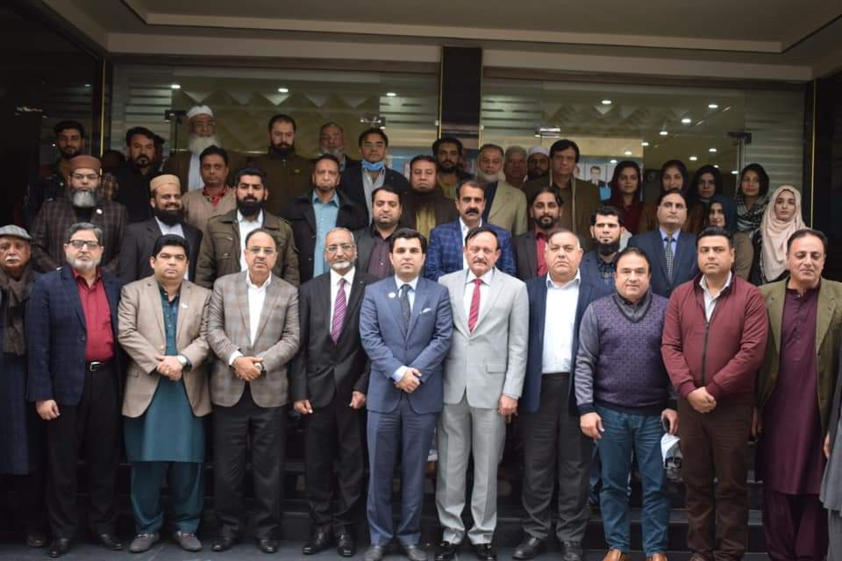
5. He also told that economy of Libya is oil based upto 95% exports and its being on top 25th position in gold reserves with per capita income of US $ 12000. He attracted the attention of the business community toward exports from Pakistan in sectors like Textiles, Pharma, Engineering, Surgical instruments, sports goods, building material, electric equipment, food, auto parts etc. He also added the Industrial Policies for trade facilitation which included Zuwara Free Trade Zone and Misrata Free Trade one which are financially and administratively independent within the boundaries of Libyan law.

*********************************

