Her Hunar Exhibition
March 4th & 5th 2023
Trade Development Authority of Pakistan (TDAP), Ministry of Commerce organized an exhibition “Her Hunar” on 4th & 5th March, 2023 at Pak-China Friendship Center, Islamabad to encourage women entrepreneurs hailing from North Pakistan including Chitral, Swat, Hazara, DI Khan, Gilgit Baltistan, Azad Jammu Kashmir, Islamabad and Rawalpindi. The event provided a platform to the women entrepreneurs for business networking, exhibiting their products, learning modern techniques, understanding marketing methods, developing products for global market and promoting exports.
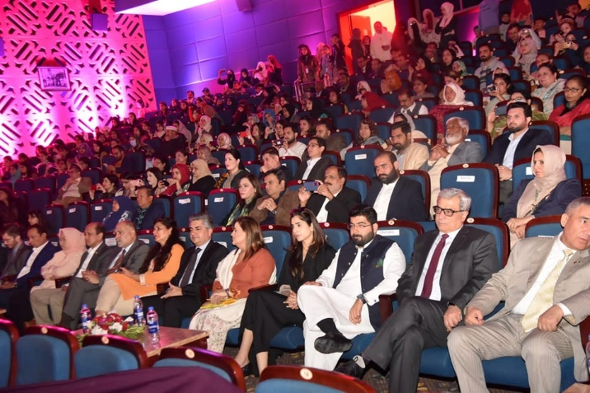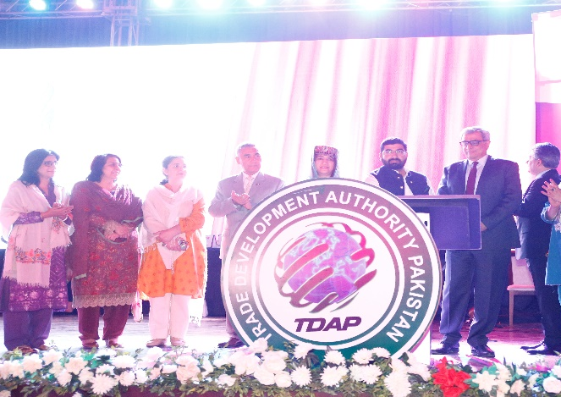
There were 139 stalls in the exhibition and 129 women led business showcased the entrepreneurial skills of women. Representation from all parts of North Pakistan was present including KPK, AJK, Gilgit Baltistan, Rawalpindi and Islamabad. They displayed a variety of quality and unique products in the exhibition. Apparel and clothing, furniture, beauty and fashion products, food products, gems & Jewelry, articles of leather, footwear, herbal products, home decors and handicrafts were exhibited in the event. Seven stalls were established with the live cooking of cultural food of Hazara, GB and Kashmir. There were 10 organizations which set up their own stalls to provide awareness to the women entrepreneurs about their women specific initiatives. The organizations include IPO Pakistan, State Bank of Pakistan, First Women Bank, Bank Al Habib, ITC, USAID, NUST, PSEB and WECamp. They provided information and educated women entrepreneurs about different initiatives related to business development, financing opportunities and legal protection.
On the sideline of the exhibition capacity building training sessions were also organized. On the first day, the focus of training was on the awareness Session on Intellectual Property Rights, Trade Facilitation Portal – Access Management and TDAP Trade Portal. One the second day, focus of training was about financial management and topics were Micro-Financing Opportunities for Women Entrepreneurs, Financial Schemes for Women Entrepreneurs, and SME e-Learning Course for Women Entrepreneurs. TDAP developed the training modules in collaboration with IPO Pakistan, ITC, SBP, First Women Bank and Akhuwat.
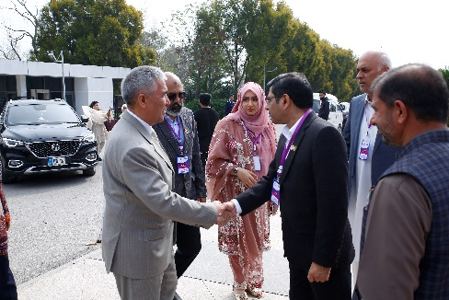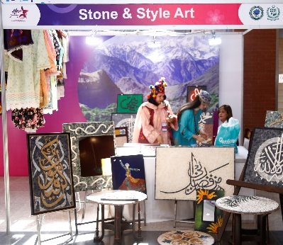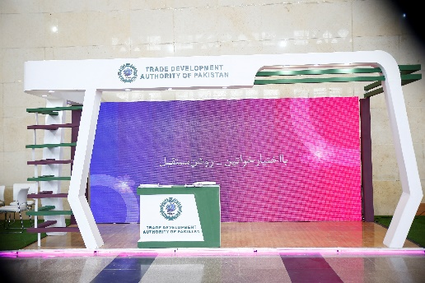
During the two days event, the foot fall was very encouraging. The visitors included parliamentarians, diplomats, Government officials, representatives of trade bodies and development partners, academia and general public. Print and electronic media was also present. The event was promoted on social media besides city branding. People from all walk of life appreciated the Her Hunar initiative of TDAP and recommended to make it an annual women led business event which will help to promote women entrepreneurship as well as exports of the country. Feedback from the exhibitors was very encouraging. They requested TDAP to hold this event for three days in future.
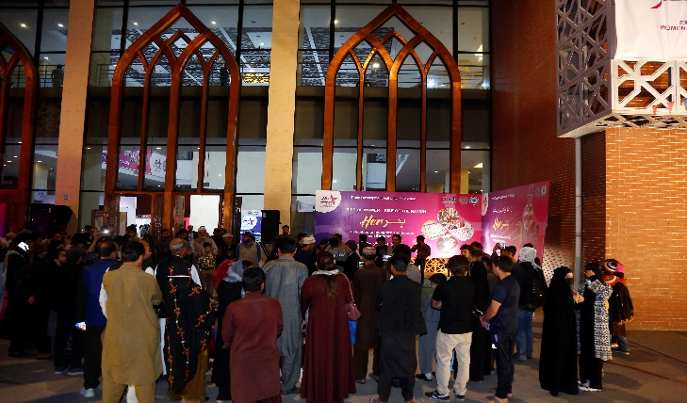

It was an effort to encourage women led businesses of less developed areas of North Pakistan. The event aimed to showcase the entrepreneurial skills of women who do not have much access to technology and information and provided them with much needed exposure and training to further polish their skills & product lines.
