Post Event Report on TDAP’s Seminar on Sustainability – Leather Sector

Title | Sustainability – Leather Sector
Meeting Date: | 20th March, 2023
Meeting Time: | 3:00 PM to 5:00 PM
Meeting Location: | TDAP Headquarters, Karachi

1. Objective(s) of the Seminar
The primary objectives and topics covered in the above trainings were;

- This second in the series seminar was organized in connection with the 4th edition of Texpo-2023 to meet the objective of its theme “Weaving the Way to Sustainability”
- The seminar was an initiative to appreciate the efforts of the local leather industry for their ambitions & aims to ensure compliance to local & international laws, customer requirements working to adopt eco-friendly practices etc.
- The Seminar aimed for readiness and focus of our stakeholders on sustainable production by adopting the different technical and social measures in the coming years
(Continued)

2. Discussion
- The T&L Division, organized the second Seminar on “Sustainability – Leather Sector” for Leather Industry on 20th March, 2023 at the 3rd Floor Conference Room, TDAP Headquarters, Karachi, wherein, other than virtual participation via zoom, more than 27 participants from leather sector, experts on environment, NGOs etc. participated.

- The seminar was organized in connection with the 4th edition of Texpo-2023 scheduled to be held on 26th to 28th May, 2023 at the Expo Center, Karachi under a dynamic theme “Weaving the Way to Sustainability” to appreciate the efforts of the local leather industry for their ambitions & aims to ensure compliance to local & international laws, customer requirements working to adopt eco-friendly practices, LWG certifications etc.

- As a keynote speaker, Mr. Amanullah Aftab, Chairman, PLGMEA & CEO, Hafiz Tanneries well briefed the facts & figures of the current scenarios of the sector and importance of LWG certification and its benefit.

- The second speaker of the seminar having a prominent portfolio in the sector was Mr. Asfandyar Farrukh, MD, HUB (Urban Brands) who put in the picture of the initiatives of his brand to adopt modern-day techniques & tactics to avoid various environment polluting practices which is common especially in the leather sector.

- The final speaker Mr. Junaid Vohra, CEO, Essential Elements Leather addressed impressively on "Why Leather Sector Go Green" and explained a few measures as a way forward towards this goal.

- The distinguished speakers from the industry shared their valuable experiences via thoughtful presentations and Q&A session.

- In his closing remarks, Mr. Basit Rauf, DG (Textiles & Leather), TDAP complimented the efforts of participants towards their interest in adopting various ' Methods' towards the common goal of Sustainability for a better environment tomorrow and invited the guests to actively participate in Texpo 2023 with its tag line ' Weaving the Way to Sustainability.
- The session was ended by presenting TDAP’s shields and a group photo

3. Conclusion / Way Forward:
The T&L Division of TDAP organized few pre-event awareness seminars on “ Sustainability” and related topics, to highlight the nuisance areas of the textiles and leather sector to identify and cope up with the current global environment challenges viz a viz obtain information in market to tackle it within the possibilities & available resources. The due merit to organize this seminar to maximum knowledge gain of modern-day environment challenges and to follow the roadmap of best business practices to minimize the damage the environment through our routine business practices.
4. Photos of the Seminar:

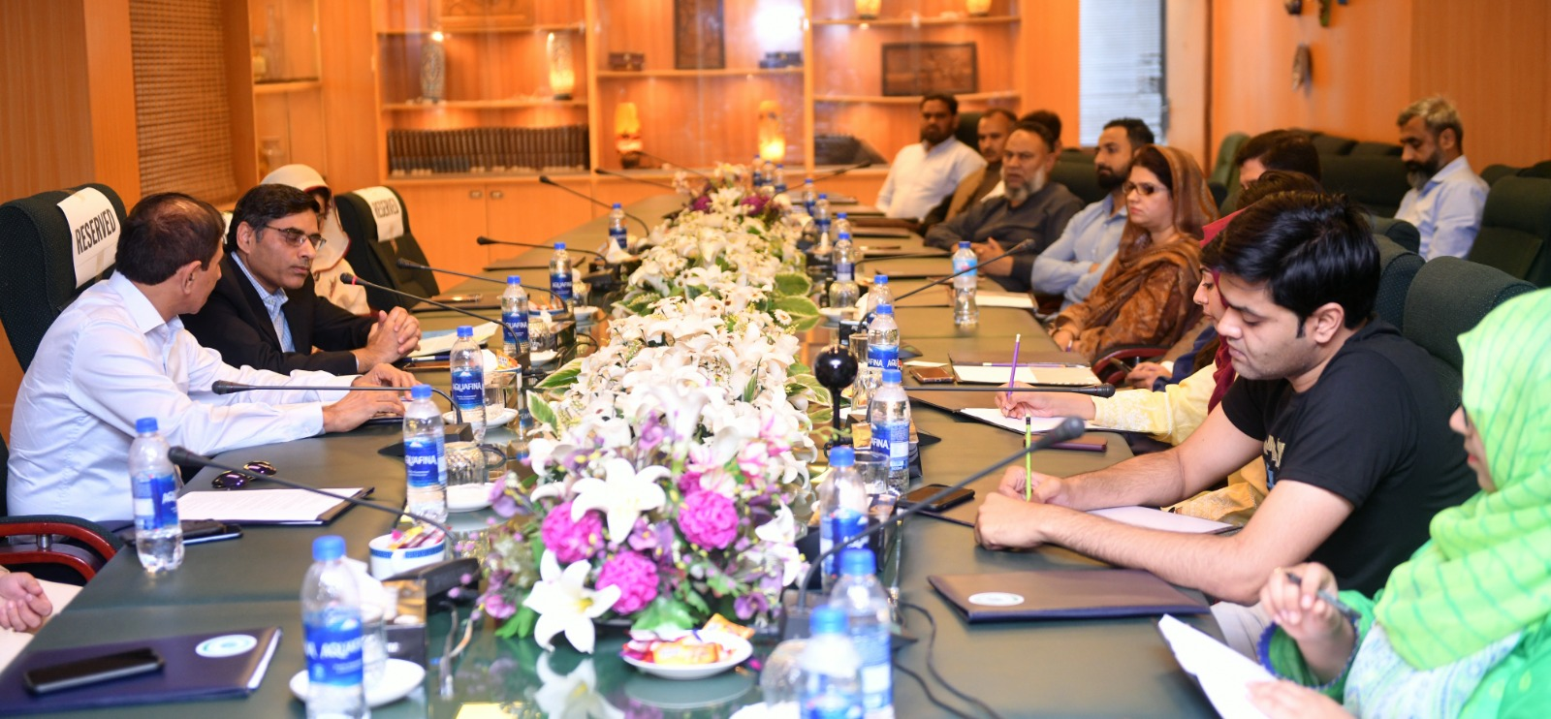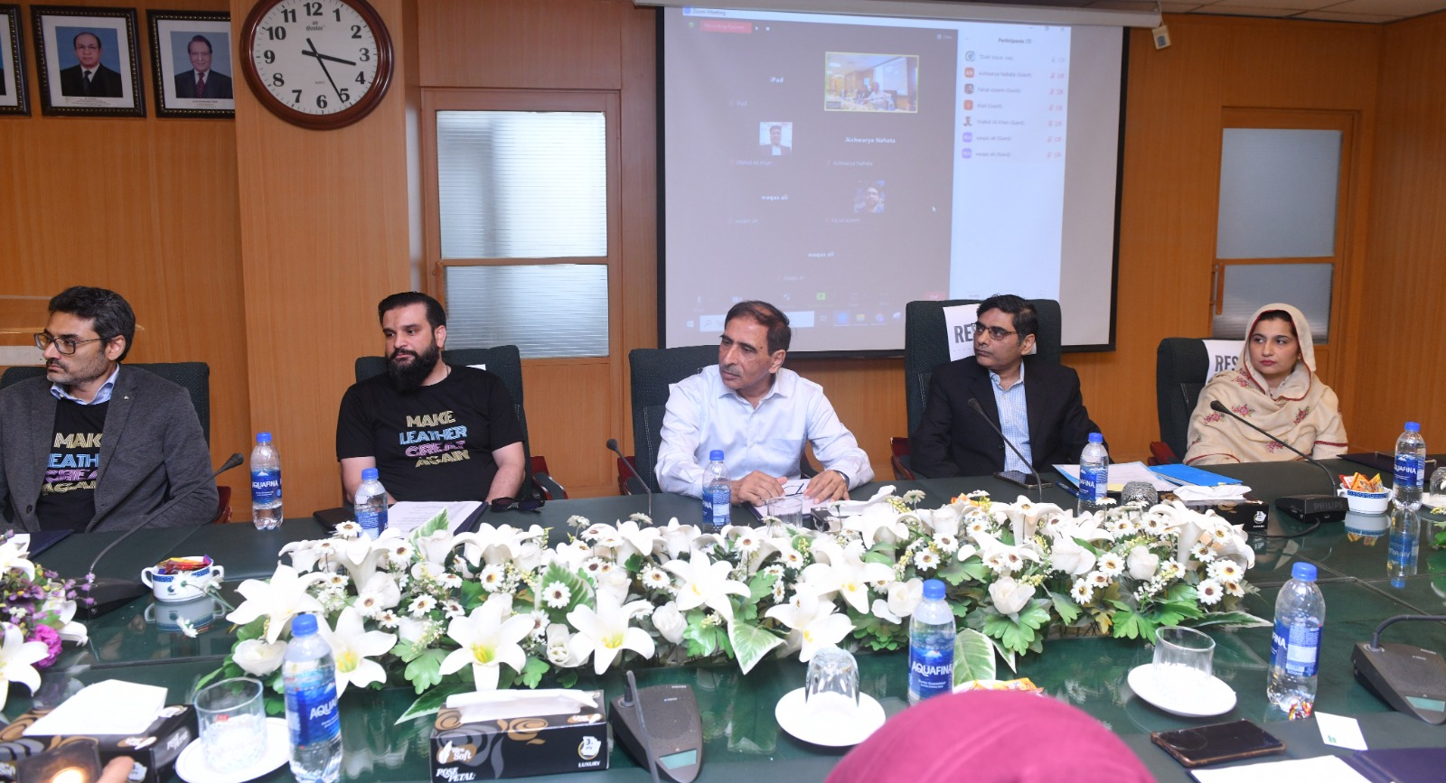
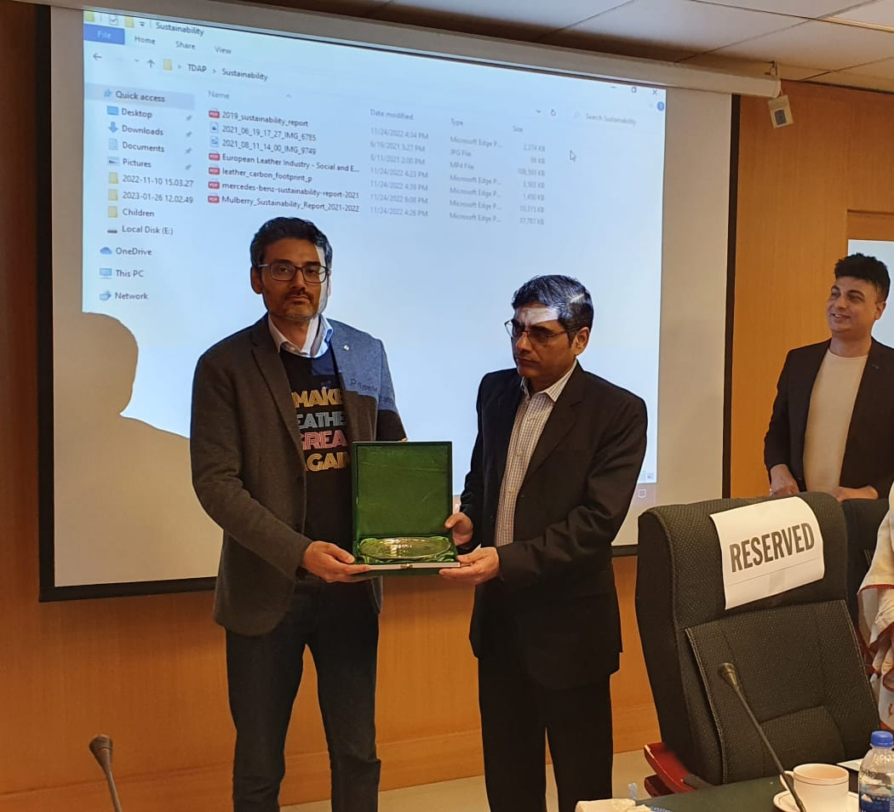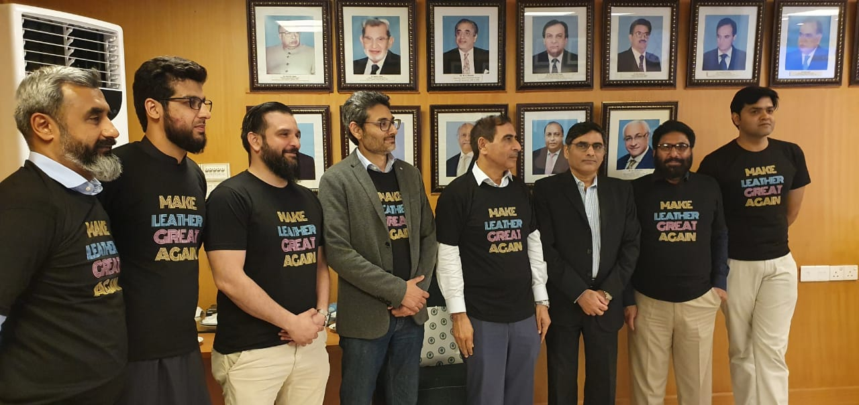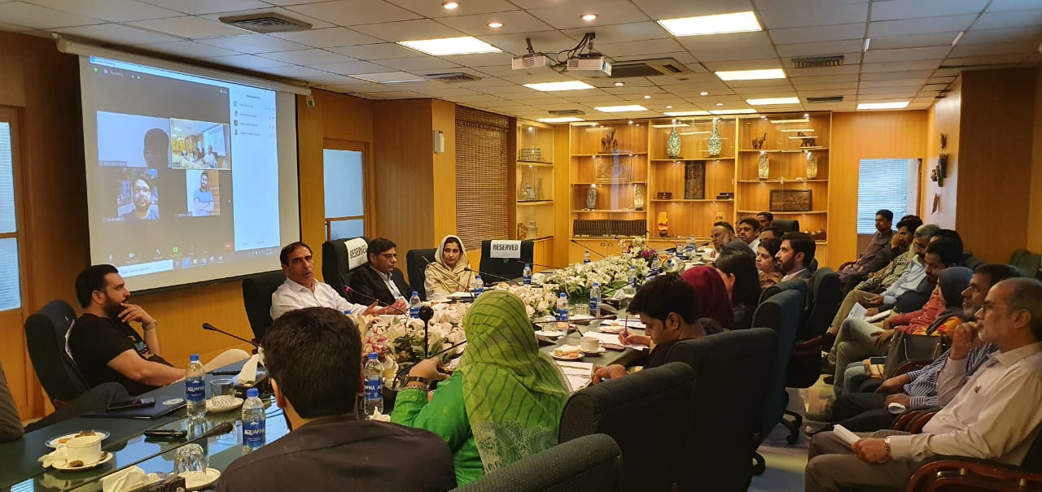

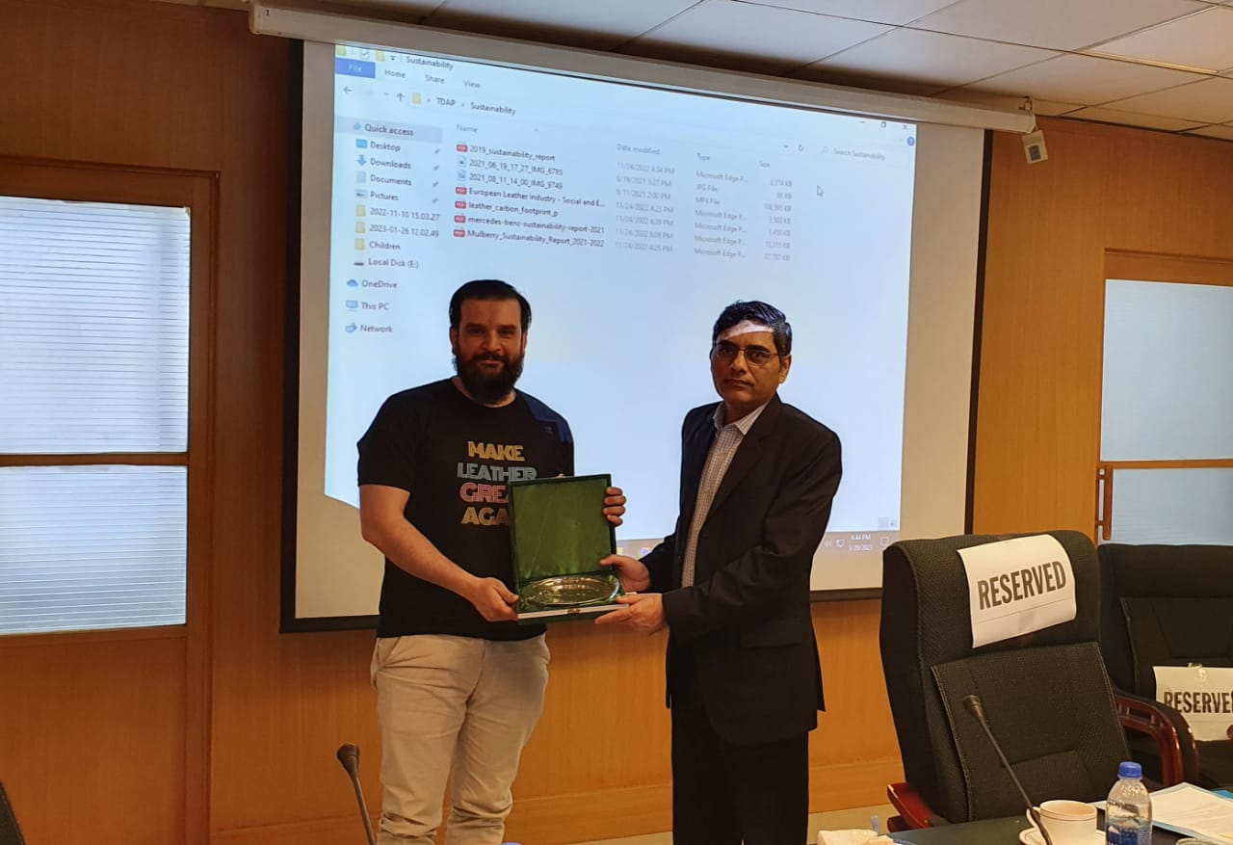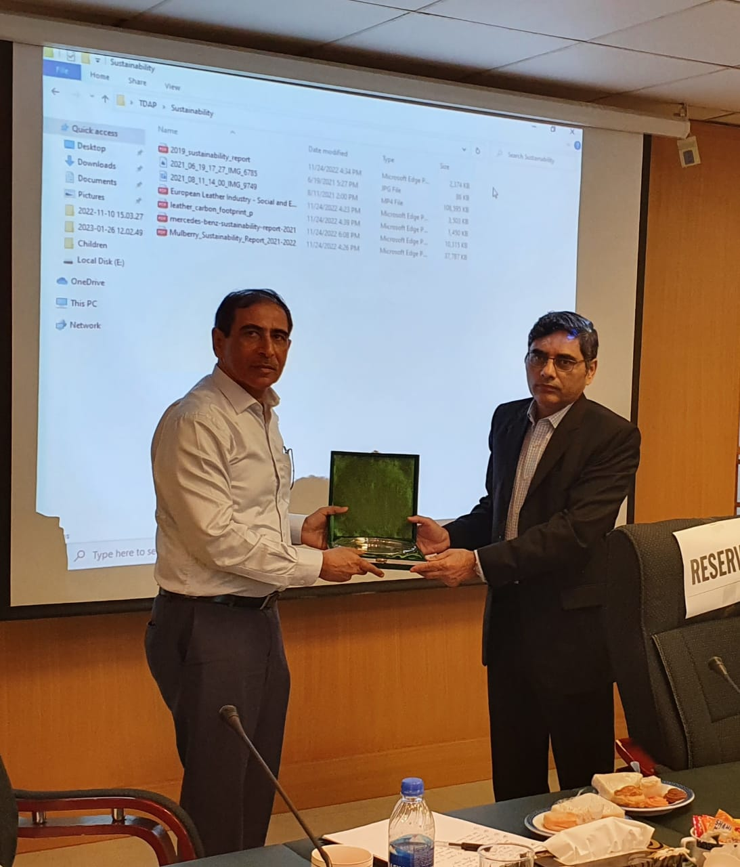

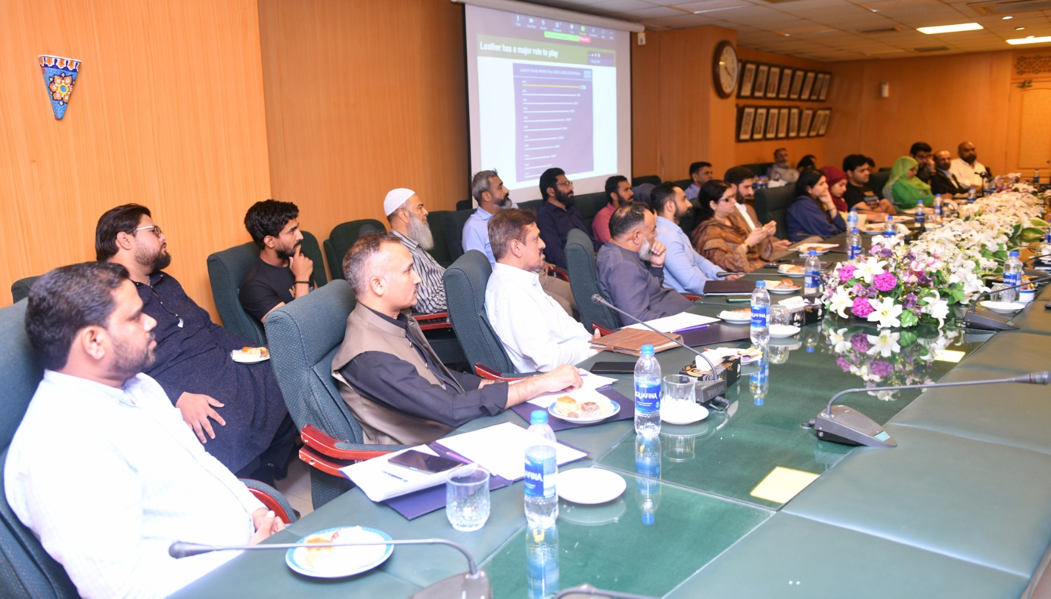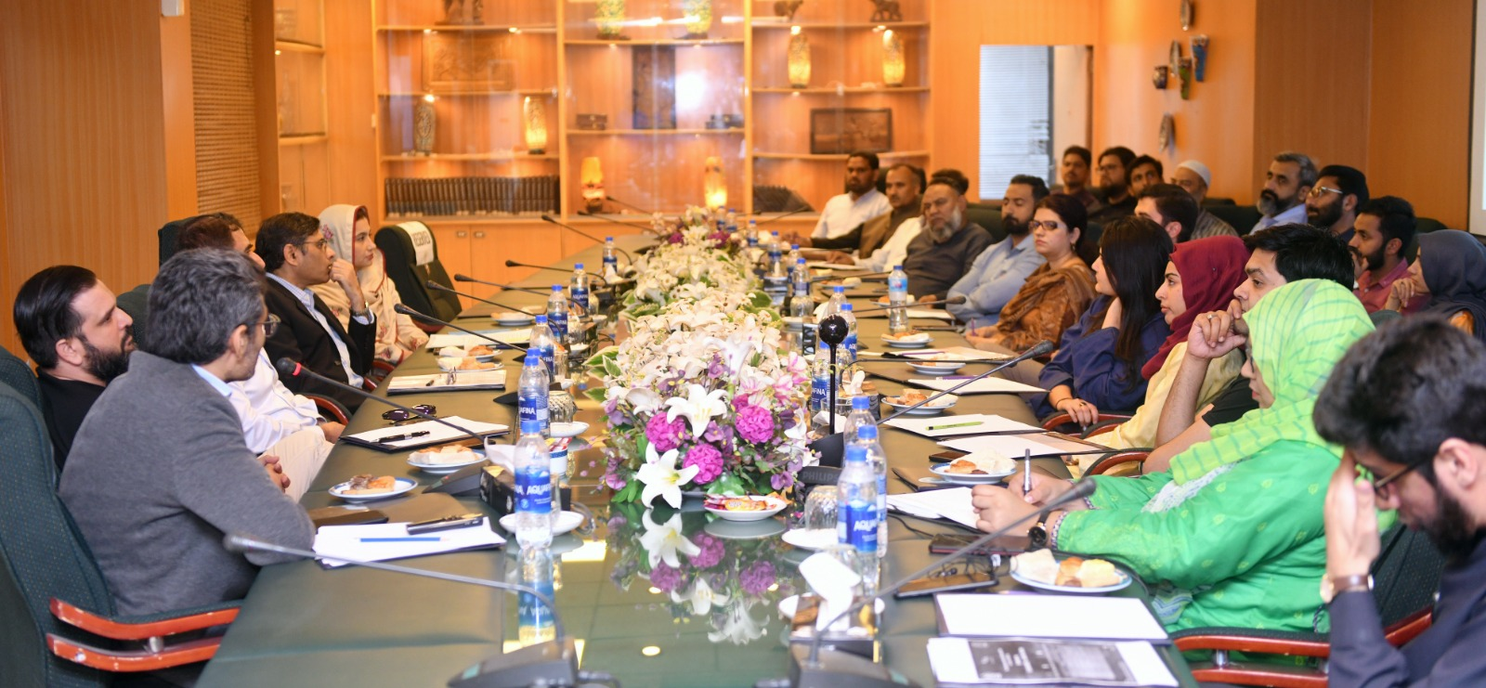

5. Evaluation Matrix Against 21 Participants (Out of 27)

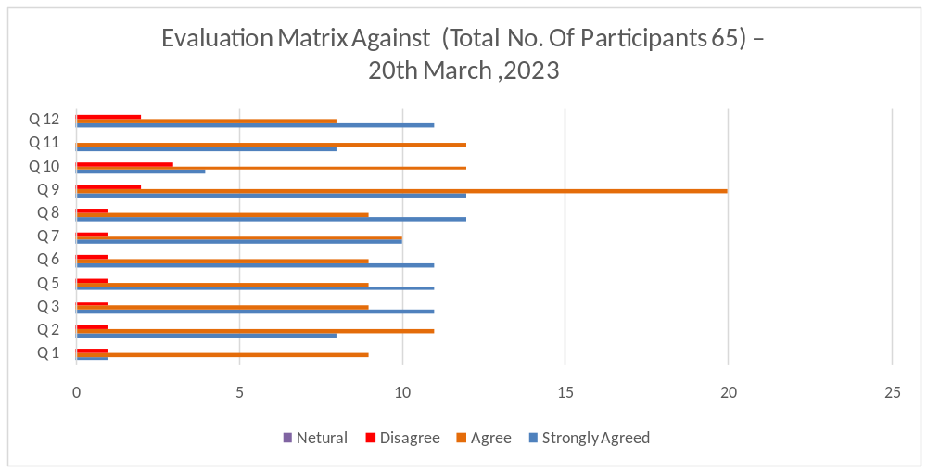
Evaluation Form Data (21 Participants)
No | Question? | Strongly Agreed | Agree | Disagree | Neutral
1 | The objectives of the training were clearly defined | 11 | 9 | 1 | -
2 | Participation and interaction were encouraged | 8 | 11 | 1 | -
3 | The topics covered were relevant to me | 11 | 9 | 1 | -
4 | The content was organized and easy to follow | 11 | 9 | 1 | -
5 | The information given was helpful | 11 | 9 | 1 | -
6 | This training experience will useful in my work | 10 | 10 | 1 | -
7 | The trainer was knowledgable about the training topics | 12 | 9 | 1 | -
8 | The trainer was well prepared | 12 | 9 | 1 | -
9 | The training objectives were met | 4 | 12 | 3 | -
10 | The time allotted for the training was sufficient | 8 | 11 | - | -
11 | The meeting room and facilities were adequate and comfortable | 11 | 8 | 2 | -

6. Press Clippings

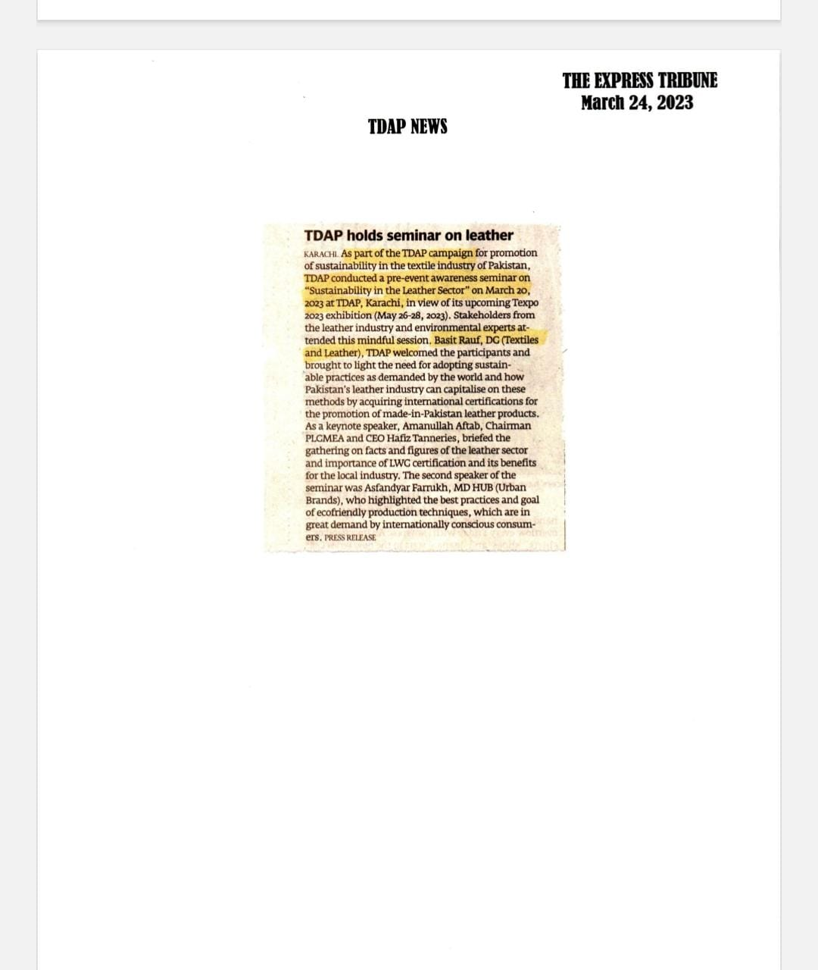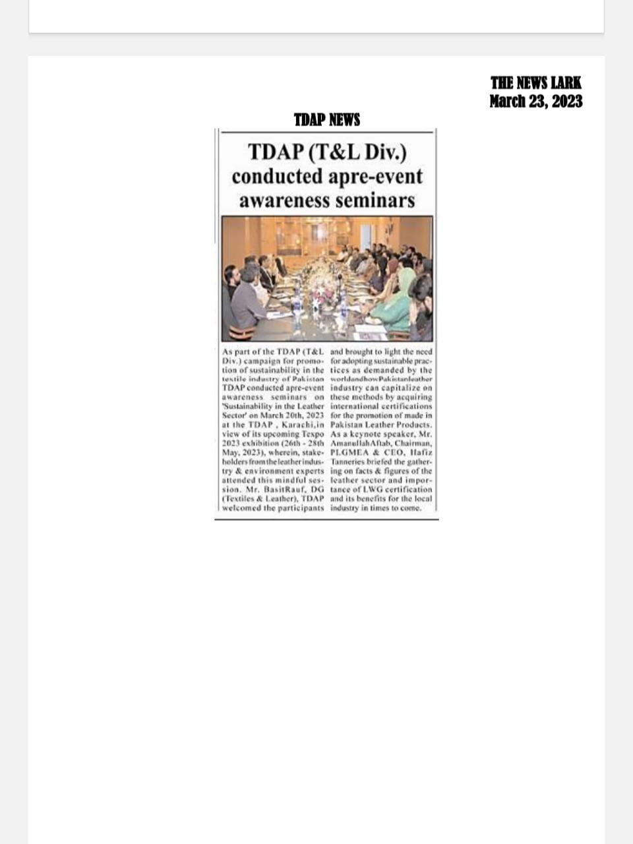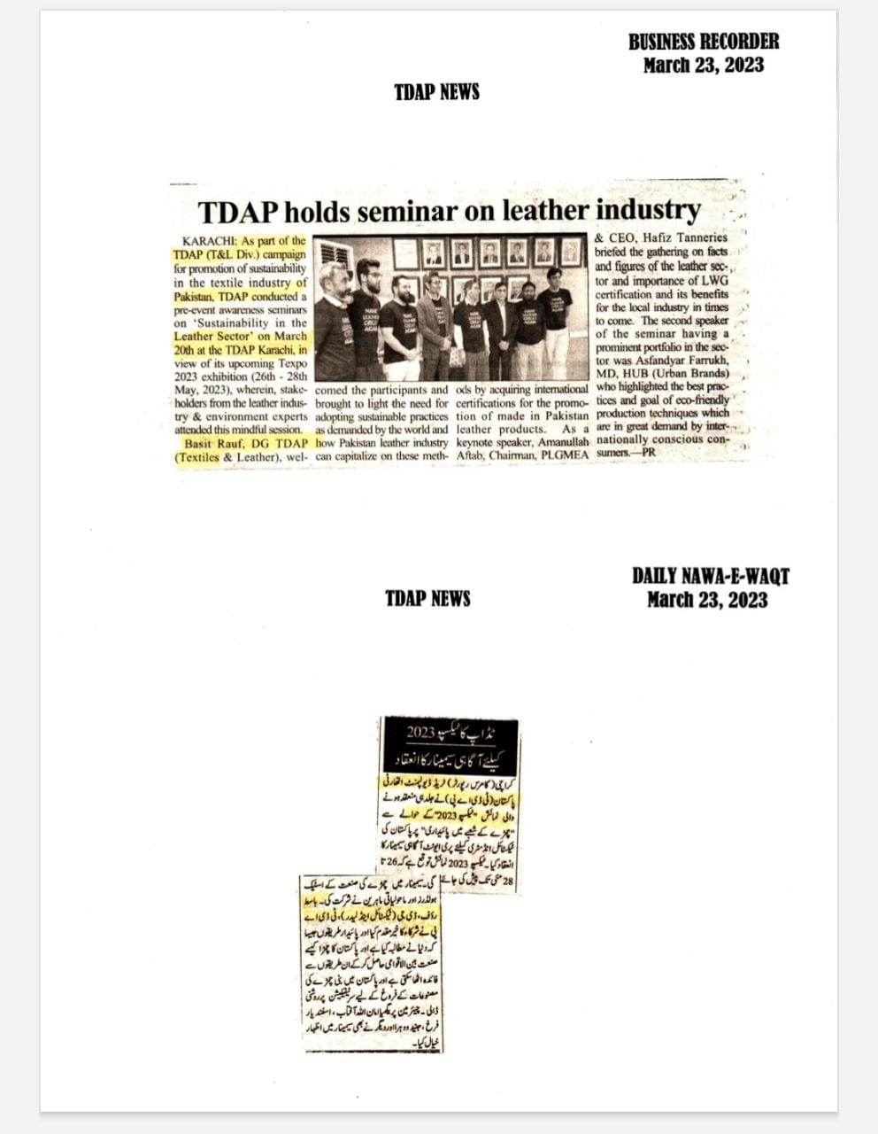

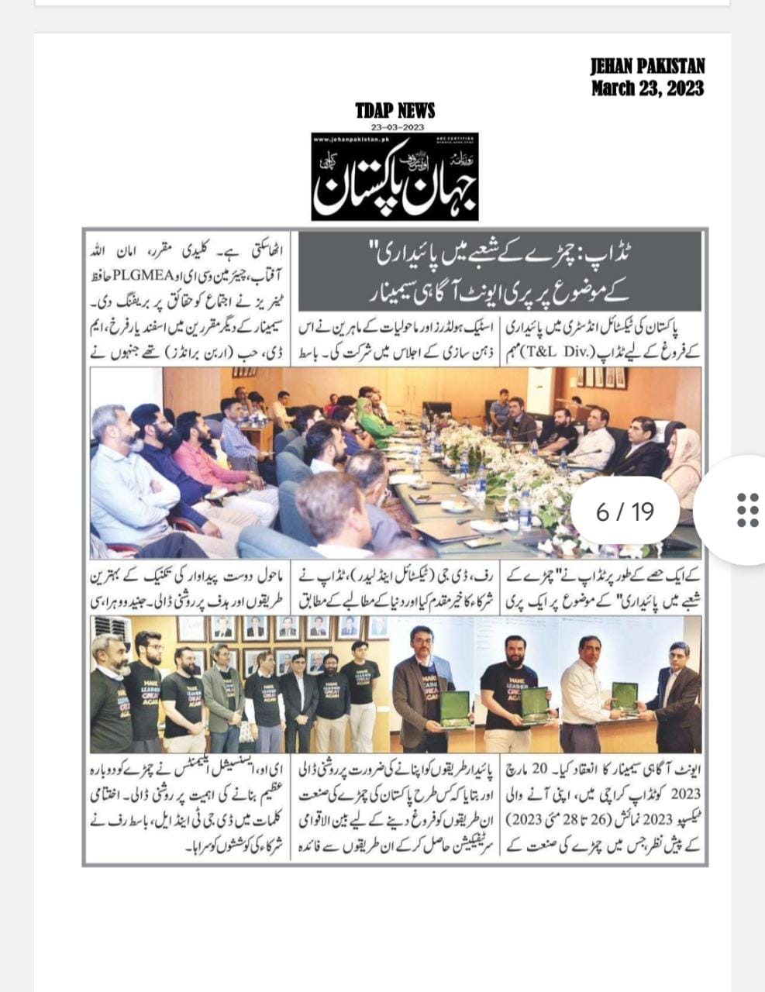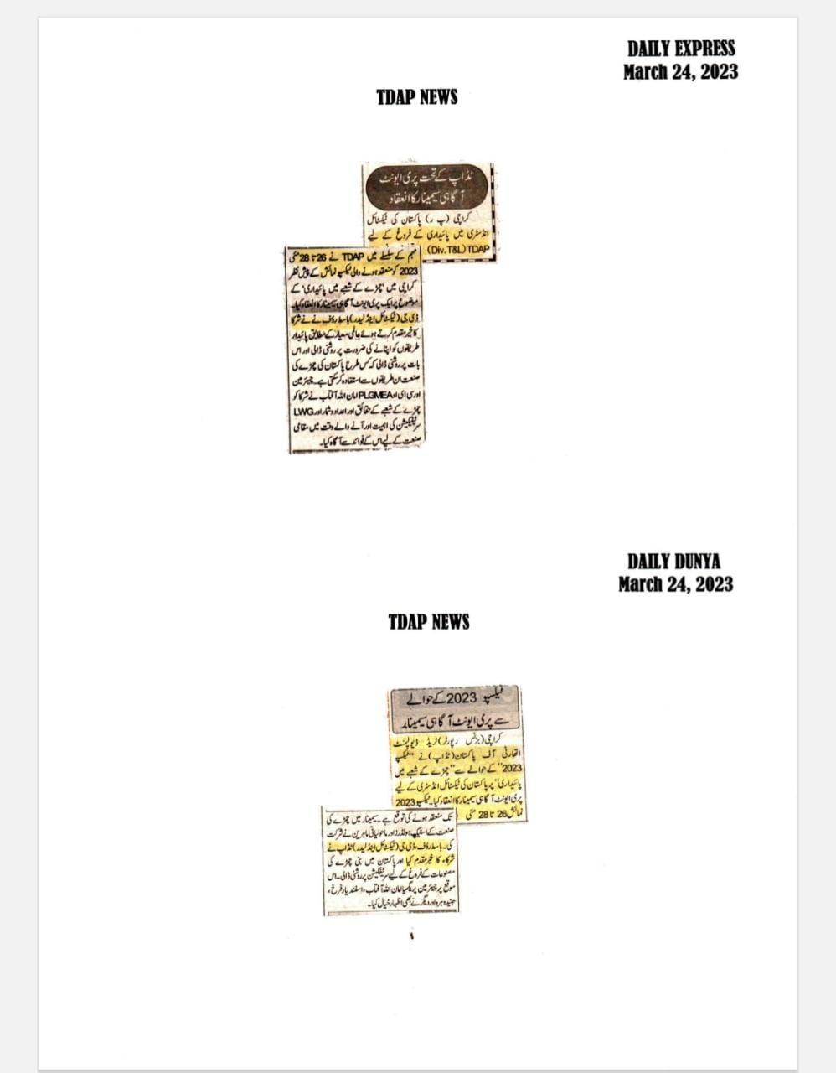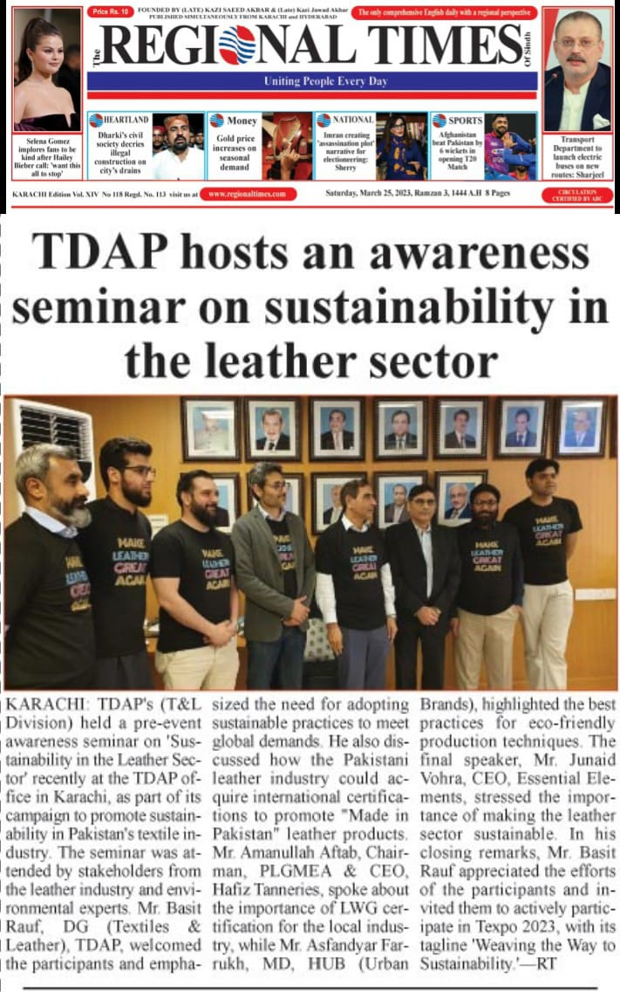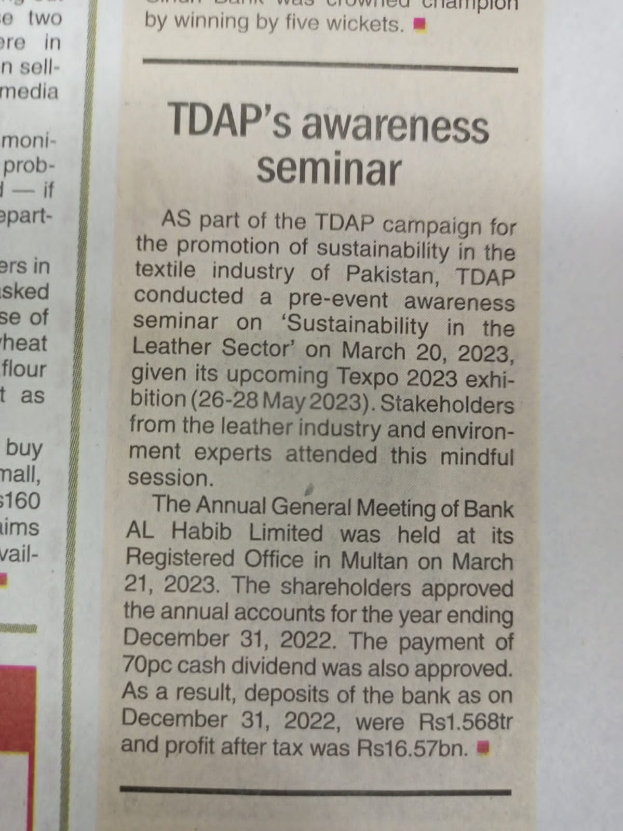

7. Participant List:
S.# | Name | Name of Company | Mobile No.
 | Mr. Atif Ashraf, Director | M/s. Muhammad Ashraf (Pvt) Ltd | 0300-8229363
 | Mr. Amanullah Aftab, Chairman PLGMEA | M/s. Hafiz Tannery | 0300-8244159
 | Mr. Arif Qureshi, | M/s .Y & Sons (Pvt.) Ltd. | 0300-8237278
 | Mr. Ghulam Mustafa  Ansari, | M/s R & D Leather | 0345-8266125
 | Mr. Syed Sameer Ali, Director | M/s The Designer | 0304 2055783
 | Mr. Syed Khurrum Raza | M/s Unite Impex | 0306 2483341
 | Muhammad Iqbal Awan, Secretary General | Pakistan Leather Garments Manufacturers  & Exporters Association (PLGMEA) | 0300 2086501
 | Anusha Fatima | TrashIt | 03132094994
 | Rahul Rai | TrashIt | 03333989674
 | Hussain Ali | BKBB Leather | 03412152680
 | Major Omar Jamal Durrani (Retd) | M/s. Midas Safety Pakistan | 0335-2300040
 | Mr. Naseem Ahmed, Director | M/s. Hamid Leather | 0300-2903252
 | Ms.Nazish Fawad Khan | M/s. Ideal (Pvt.) Ltd. | 0321-3744410
 | Kumail Ali Jaffry | Essential Element | 0333 3290544
 | Mr. Hamza | M/s Abu Hurara Tannery, | +92-322-2407-937
 | Mr. Sharukh | M/s Abu Hurara Tannery, | +92-312-0820-706
 | Mr. Sajid Ali | M/s Aqsa Industries (Pvt) Ltd, | 0300-0643759
 | Dr. Muhammad Yousuf Awan | Environment Expert | 0300-2086501
 | Mr. Tahir Rizwan | Environment Expert | 0300 2773043
20 | Mr. Shaukat Ali | M/s Essential Elements Leather | 0300 9206428
21 | Mr. Asfandyar Farrukh | M/s Hub (Urban Brands) | -
22 | Dr. Insia Fatima | Ideal (Pvt.) Ltd./ | 0332 4111998
23 | Mr. Hammad Sherjee | M/s Essential Elements Leather | 0324 2433263
24 | Mr. Nadeem Iqbal | M/s Nadeem Intertrade | 0333 2112424
25 | Mr. M. Nafees | M/s Hub Leather (Pvt.) Ltd. | 0343 2021235
26 | Mr. Shabbir Ahmed | M/s Hub Leather (Pvt.) Ltd. | 0300 2720073
27 | Muhammad Muslim | M/s Abiha Traders | 0321 2206331

********************************

