**Post Event Report on TDAP’s Seminar on**

**“Sustainability in Textile & Leather Sector”**

| **Title** | “Sustainability in Textile & Leather Sector” |
| --- | --- |
| **Meeting Date:** | 25th September, 2024 |
| **Meeting Time:** | 2:00 PM to 5:00 PM |
| **Meeting Location:** | TDAP Headquarters, Karachi |
| **No. of Participants** | 35 |

|  |  |
| --- | --- |
| 1. Objective(s) of the Seminar | |
| The primary objectives and topics covered in the above trainings were;   1. Strong emphasis on Sustainability and related issues through a series of Pre-Texpo awareness seminars focusing on Circularity, Recycling, Up cycling in the textile & leather industry, 2. Educating stakeholders and promoting best practices by featuring the adoption of eco-friendly materials, improvements in energy efficiency, recycling and up cycling of textiles, and the development of closed-loop production systems that minimize waste. 3. Growing emphasis on ethical sourcing and improving labor conditions throughout the supply chain. 4. Encourage the adoption of sustainable practices in the industry, supporting the transition towards a more environmentally responsible and socially conscious textile sector in Pakistan. | |
| ***(Continued)*** |
| 2. Discussion:  * As part of its ABP 2024-25, the T&L Division has planned to host a series of Pre-Texpo awareness seminars focusing on sustainability in the textile industry, with the goal of educating stakeholders and promoting best practices. These seminars will feature the adoption of eco-friendly materials, improvements in energy efficiency, recycling and up cycling of textiles, and the development of closed-loop production systems that minimize waste. * The seminar was successfully held with the aim of providing a platform for SMEs and industry leaders in the textile and leather sectors to discuss challenges, share insights, and explore innovative solutions for promoting sustainability. This initiative is part of TDAP’s broader efforts to foster sustainable practices in these industries, supporting the transition towards a more environmentally responsible and socially conscious textile and leather sector in Pakistan. * **Opening Remarks:** Mr. Hasnain Azhar, Deputy Director of TDAP, welcomed the participants and highlighted TDAP’s ongoing initiatives focused on sustainability in the textile industry. He emphasized the importance of educating stakeholders and promoting best practices through the adoption of eco-friendly materials, improvements in energy efficiency, recycling and upcycling of textiles, and the development of closed-loop production systems to minimize waste. * **Keynote Address:** The first speaker, Mr. Fahad Juma, Senior General Manager at Gul Ahmed Ltd., presented Gul Ahmed’s Sustainability Roadmap. He elaborated on the company's efforts to improve labor conditions throughout the supply chain and its commitment to ethical sourcing practices. Mr. Juma emphasized how these initiatives contribute to a more sustainable and responsible textile industry. * **Denim Industry Perspective:** Mr. Muhammad Raza Khemji, CEO of SABF and former General Manager at Siddiqsons Ltd., discussed the critical role of the denim industry in addressing climate change. He highlighted that denim production is globally recognized as one of the most polluting sectors, with significant sustainability challenges, particularly in our region. These challenges include high carbon emissions, excessive use of chemicals impacting ecosystems and human health, substantial water consumption leading to scarcity, and labor concerns related to working conditions and human rights. * **Leather Sector Insights:** Mr. Muhammad Junaid Vohra, CEO of Essential Element, provided an in-depth analysis of the sustainability challenges faced by the leather industry. He showcased an impressive line of value-added products made from leather waste, demonstrating how his company is integrating sustainable practices into product development. His presentation underlined the potential of turning waste into high-quality products, thereby promoting a circular economy within the leather sector. * The final speaker of the seminar, **Mr. Shamim Ahmed Shamsi,** CEO of Zona Pakistan (Pvt.) Ltd., highlighted the sustainability features within the textile and fashion design industry. He discussed past sustainable practices that, with a few modern adaptations, could still be highly effective today. Mr. Shamsi’s insights emphasized the importance of integrating traditional methods with contemporary innovations to achieve a more sustainable future for the industry. * The distinguished speakers shared their valuable experiences through engaging presentations, thought-provoking videos, and interactive Q&A sessions, providing the audience with a comprehensive understanding of sustainability in the textile and leather sectors. * In his closing remarks, **Mr. Basit Rauf,** Director General (Textiles & Leather) at TDAP, expressed his sincere gratitude to all the participants for their contributions. He emphasized the need for continued efforts and collaboration to implement broader sustainable practices, aiming towards the shared goal of a greener and more environmentally responsible Pakistan. * The session was ended with shield presentations by TDAP to distinguished speakers, certificate distribution and group photos. | | | |
| 3. Conclusion / Way Forward: | | | |
| - In the Seminar on “Sustainability in Textile and Leather Sector” **has put a** strong emphasis on **sustainability** and related with a focus on **circularity**, **recycling**, and **upcycling** etc. It also highlighted innovative approaches to reducing waste and promoting resource efficiency. The seminar aimed at educating stakeholders in promoting **best practices**, featuring the adoption of **eco-friendly materials**, improvements in **energy efficiency**, and the integration of recycling and upcycling processes. Additionally, it focussed on developing **closed-loop production systems** that minimize waste and environmental impact, further contributing to a sustainable future. Through this seminar, **increasing** attention was given to **ethical sourcing** and improving **labor conditions** throughout the supply chain. These efforts are designed to ensure that sustainability is not only about environmental responsibility but also about **social welfare** and **fair practices** within the industry.  **-** Participants were encouraged to adopt sustainable practices that support the **transition** towards a more **environmentally responsible** and **socially conscious** textile and leather sector in Pakistan, with the goal of fostering long-term positive change in the industry and greener Pakistan. | | | |

**4. Photos of the Seminar:**

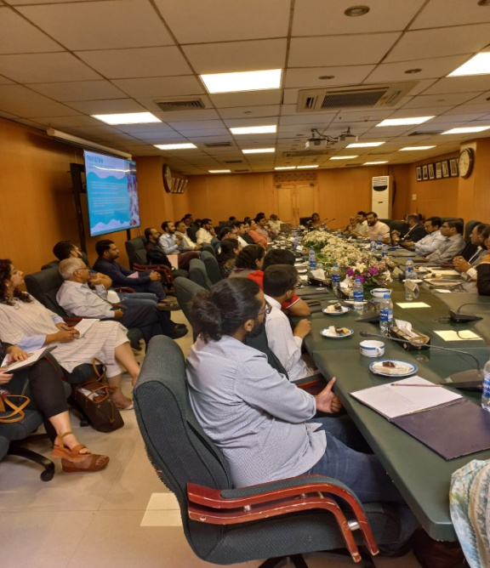 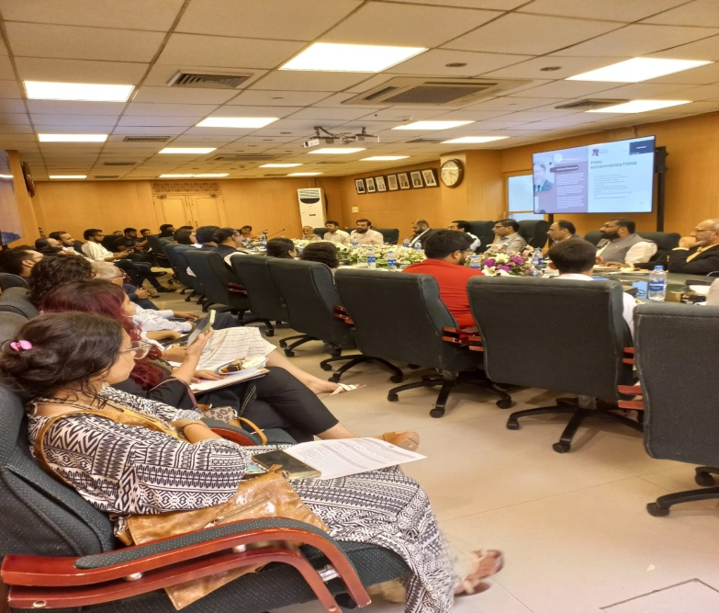

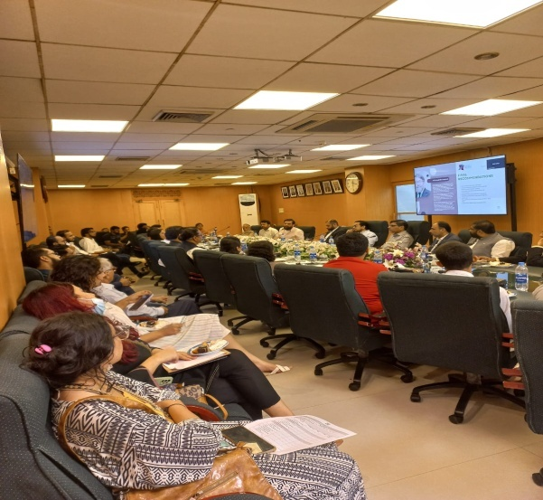 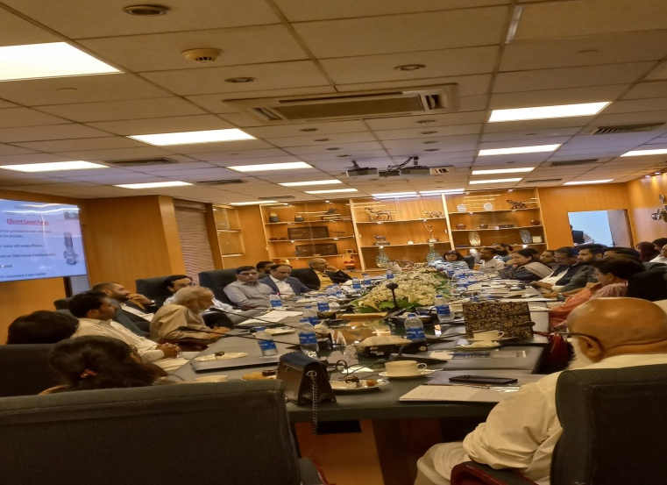

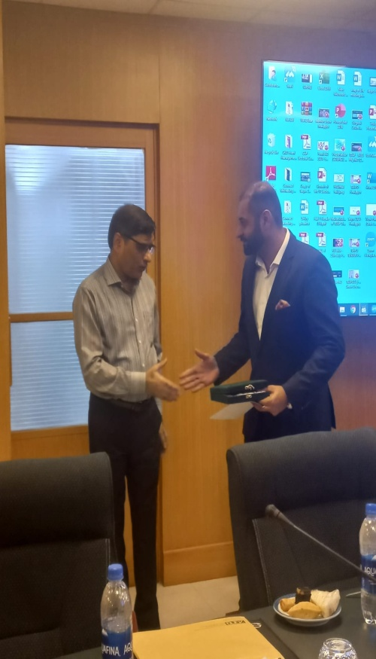 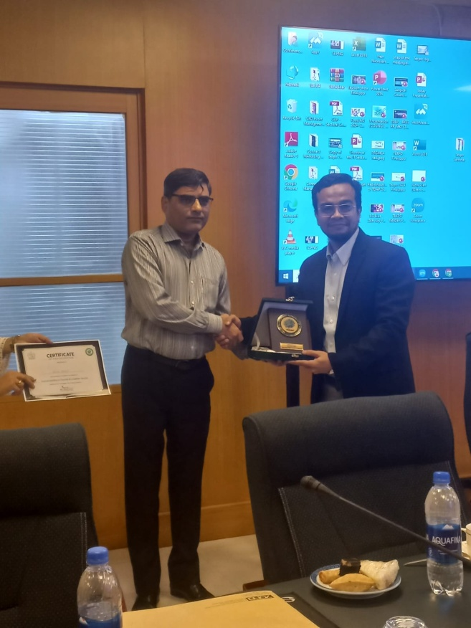

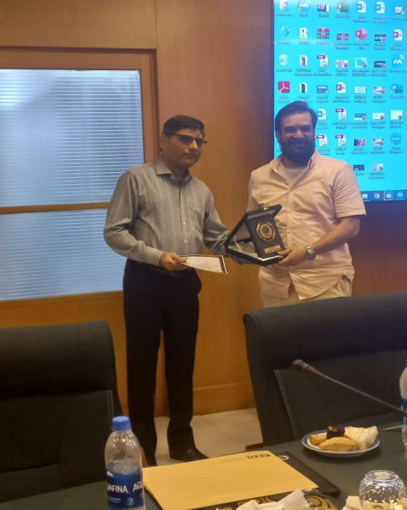 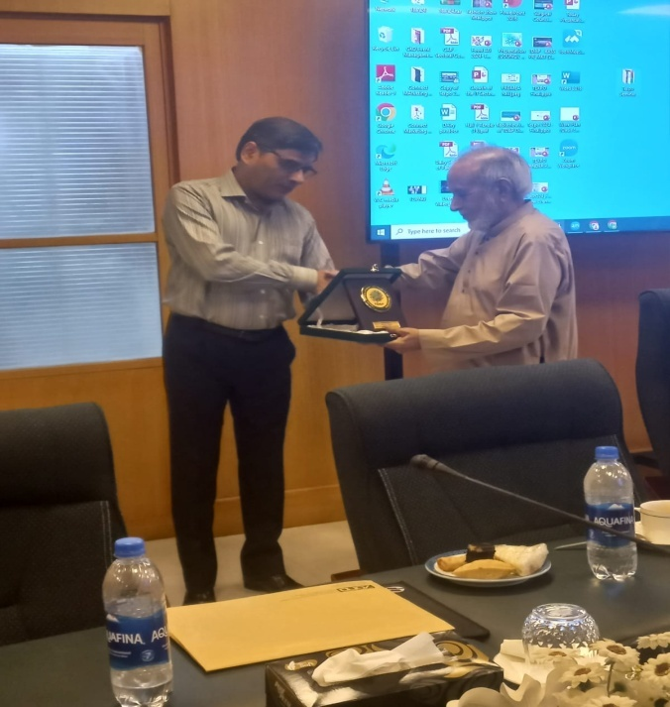

**5. Evaluation Form Data (35 Participants attended in person)**

|  |
| --- |
|  |

|  |  |  |  |  |  |
| --- | --- | --- | --- | --- | --- |
| **No** | **Question?** | **Strongly Agreed** | **Agree** | **Disagree** | **Neutral** |
| 1 | The objectives of the training were clearly defined | 12 | 9 | - | - |
| 2 | Participation and interaction were encouraged | 10 | 10 | - | - |
| 3 | The topics covered were relevant to me | 9 | 12 | - | - |
| 4 | The content was organized and easy to follow | 11 | 8 | - | - |
| 5 | The information given was helpful | 12 | 9 | - | - |
| 6 | This training experience will useful in my work | 13 | 6 | - | - |
| 7 | The trainer was knowledgable about the training topics | 13 | 7 | 1 | - |
| 8 | The training objectives were met | 7 | 12 | - | - |
| 9 | The time allotted for the training was sufficient | 7 | 11 | 2 | - |
| 10 | The meeting room and facilities were adequate and comfortable | 7 | 12 | 2 | - |
| 11 | Remarks (if any) | Very Good | | | |

**6. List of Participants (35 Participants attended in person)**

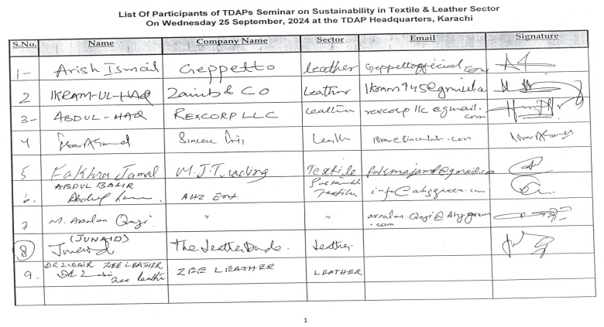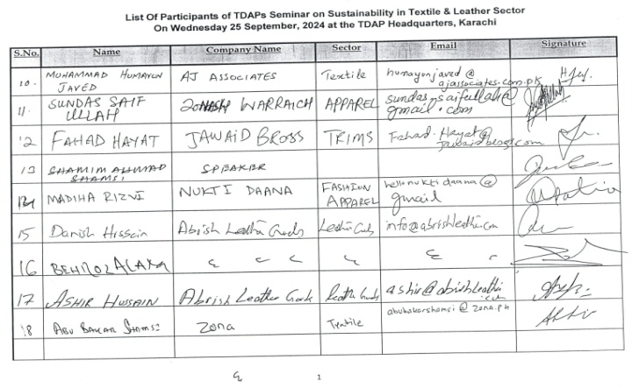

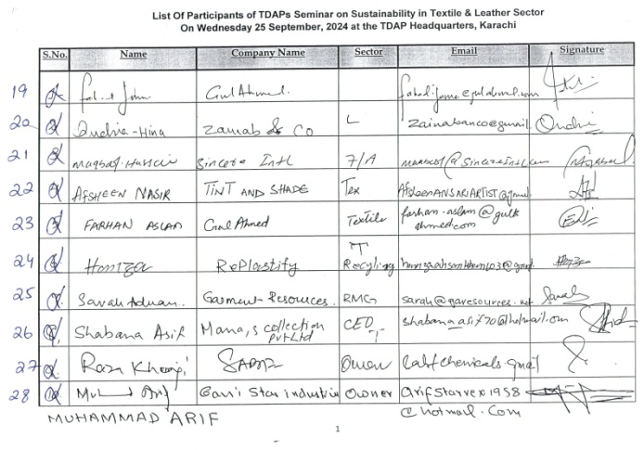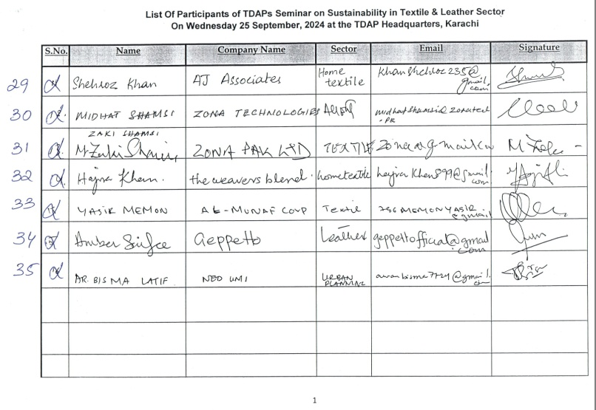

**7. Press Clippings**



